Introduction:
I was born in Nalanda, a small district in Bihar. Later, I shifted to Navi Mumbai with my parents. I completed my schooling at Kendriya Vidyalaya ONGC Panvel and my graduation in Electronics from Lokmanya Tilak College of Engineering. After that, I pursued my PG Diploma in Advanced Computing from Bandra.

I have about 2.4 years of work experience in Core Java, Oracle, Git, and Jira. The project I worked on was Pristima Core. I contributed to backend development using Java, Spring Boot, and Oracle DB for the Pristima platform, which is used in regulatory compliance and preclinical data management.

I improved system performance by rewriting and upgrading key calculations using Java 8 features, which increased processing speed by about 30%. I also created reusable components and services that supported different business modules. Through this work, I gained a strong functional understanding by contributing across different product versions.
What is Java?
Java is a versatile programming language used for building applications across various platforms.
Java is object-oriented, promoting code reusability. Example: Inheritance allows a subclass to inherit properties from a superclass.
Java has a rich API and extensive libraries, such as Java Collections Framework for data manipulation.
Java is platform-independent due to the Java Virtual Machine (JVM), enabling 'write once, run anywhere'.
Java supports multithreading, allowing concurrent execution of two or more threads for efficient resource utilization.
Java is widely used in enterprise applications, mobile apps (Android), and web development.

Why Java is object-oriented (explained with simple examples)?
Java is called an object-oriented programming (OOP) language because it is built around objects and classes. OOP helps you model real-world things with code, and Java gives you the main OOP features: encapsulation, inheritance, polymorphism, and abstraction. Below I explain each feature, show how Java implements it, and give a short code example that ties them together.
how java handle memory managment?
Java uses an automatic memory management system, mainly handled by the JVM (Java Virtual Machine) through something called the Garbage Collector (GC).This means you (the programmer) don’t need to manually allocate or free memory (unlike in C/C++ with malloc and free).
🔸 1. JVM Memory Areas: When you run a Java program, JVM divides memory into different parts:
🟢 Heap Area:Where all objects and their instance variables are stored.
Shared among all threads.
Managed by the Garbage Collector.
Example:
String s = new String("Hello");
→ The object "Hello" lives in the heap.
🔵 Stack Area
Stores method calls, local variables, and references to objects.
Each thread has its own stack.
Variables are destroyed once the method ends.
Example: void test() {
int x = 10; // x stored in stack}
🟣 Method Area (or MetaSpace from Java 8)
Stores class metadata, static variables, method code, etc.
Example: static int count; // stored in method area
🟠 Program Counter (PC) Register
Keeps track of the current instruction being executed.
Each thread has its own PC register.
🟡 Native Method Stack
Stores native (non-Java) method calls, like those written in C/C++ using JNI.
🔸 2. Garbage Collection (GC)
Java automatically frees memory with GC.
GC runs in the background.
It removes objects from the heap that are no longer referenced.
Example:
String s1 = new String("Hi");
String s2 = new String("Bye");
s1 = s2; // "Hi" has no reference now → eligible for GC
GC uses algorithms like:
Mark and Sweep → Marks reachable objects, removes unreferenced ones.
Generational GC → Divides heap into Young Generation (new objects), Old Generation (long-living objects), Permanent Generation (class metadata).
🔸 3. Memory Leaks in Java?
Even though Java has GC, memory leaks can still happen if references aren’t cleared properly.
Example:
List<String> list = new ArrayList<>();
while(true) {
list.add("data"); // keeps growing, never released → memory leak
}

🔸 4. How Java Handles Memory Safely
Automatic allocation: When you use new, memory is allocated from the heap.
Automatic deallocation: GC cleans unused objects.
No pointer arithmetic: Unlike C++, Java doesn’t allow direct memory manipulation → prevents errors.
Finalization (deprecated in newer Java): Before GC removes an object, it could call finalize(), but now replaced by try-with-resources and AutoCloseable.
🔹 Example Walkthrough
public class MemoryDemo {
public static void main(String[] args) {
int a = 10; // stored in stack
String name = "Java"; // string literal stored in String pool (method area)
String obj = new String("Hello"); // object in heap, reference in stack
}
}
a → stack
"Java" → String pool (method area)
obj reference → stack, "Hello" object → heap
✅ In short:
Java divides memory into stack, heap, method area, etc.
Objects → heap, local variables → stack, class data → method area.
Garbage Collector automatically cleans up unreferenced objects.

### **1. Explain OOPs concepts with examples.**
OOP (Object-Oriented Programming) has 4 main pillars:
* **Encapsulation** → Binding data and methods together.
*Example:* A `BankAccount` class hides balance details using `private` variables and exposes only getter/setter methods.
* **Inheritance** → Reusing properties of one class into another.
*Example:* `class Dog extends Animal`.
* **Polymorphism**
Polymorphism is the ability of an object to take on multiple forms. It can be achieved through method overloading and overriding.Method overloading is when multiple methods have the same name but different parameters. The compiler decides which method to call based on the arguments passed.Method overriding is when a subclass provides its own implementation of a method that is already present in its parent class. The method signature remains the same.
Polymorphism allows for code reusability and flexibility. It enables objects to be treated as their parent class or as their own class.
→ One method behaves differently based on context.
*Example:* Method Overloading (`add(int, int)` & `add(double, double)`), Method Overriding (`toString()` method).
* **Abstraction** → Hiding implementation and showing only functionality.
*Example:* `interface Payment` with `processPayment()` method, implemented by `CreditCardPayment` and `UPIPayment`.
### **2. What are the new features in Java 8?**
1) Lambda expressions & Functional Interfaces
What: A compact way to represent an anonymous function — i.e. code you can pass around.
Why: Removes boilerplate (anonymous inner classes) and enables functional-style APIs (Streams).
@FunctionalInterface
interface Calculator { int calc(int a, int b); }
public class LambdaExample {
public static void main(String[] args) {
Calculator add = (a, b) -> a + b; // lambda
System.out.println(add.calc(2, 3)); // prints 5

// Using lambda for sorting
List<String> names = Arrays.asList("Bob", "Alice", "John");
Collections.sort(names, (s1, s2) -> s1.compareTo(s2));
names.forEach(System.out::println); // method reference (see below)
}
}
2) Method references (::)
What: Shorter form of a lambda that refers to an existing method (Class::method, instance::method, Class::new).
Why: Cleaner and more readable.
List<String> names = Arrays.asList("a", "b", "c");
names.forEach(System.out::println); // prints each name
List<String> upper = names.stream().map(String::toUpperCase).collect(Collectors.toList());
3) Streams API (java.util.stream)
What: A pipeline-style API for processing collections (map, filter, reduce, collect).
Why: Concise, expressive, supports parallel execution easily.
List<String> list = Arrays.asList("apple", "banana", "avocado", "pear");
List<String> result = list.stream()
.filter(s -> s.startsWith("a"))
.map(String::toUpperCase)
.sorted()
.collect(Collectors.toList());
System.out.println(result); // [APPLE, AVOCADO]

// parallel example:
long count = list.parallelStream().filter(s -> s.length() > 4).count();
System.out.println(count);
4) Optional<T>
What: Container that may or may not hold a non-null value.
Why: Helps avoid NullPointerException and makes "absent value" explicit.
String name = null;
Optional<String> opt = Optional.ofNullable(name);
System.out.println(opt.orElse("Unknown")); // prints "Unknown"
opt.ifPresent(n -> System.out.println("Hello " + n));
String upper = opt.map(String::toUpperCase).orElse("NO NAME");
System.out.println(upper);
5) New Date & Time API (java.time)
What: Modern, immutable date/time API (LocalDate, LocalDateTime, ZonedDateTime, Instant, Duration, Period, DateTimeFormatter).
Why: Replaces the old java.util.Date / Calendar with a clearer, less error-prone API.
LocalDate today = LocalDate.now();
LocalDate birthday = LocalDate.of(1990, Month.JANUARY, 15);
Period age = Period.between(birthday, today);
System.out.println("Age: " + age.getYears());
LocalDateTime now = LocalDateTime.now();
DateTimeFormatter fmt = DateTimeFormatter.ofPattern("yyyy-MM-dd HH:mm");
System.out.println(now.format(fmt));
6) Default and static methods in interfaces
What: Interfaces can provide default implementations and static methods.
Why: Allows adding new methods to interfaces without breaking existing implementations (important for evolution of library APIs).
interface Greeter {
default void hello() { System.out.println("Hello from default"); }
static void info() { System.out.println("Greeter info"); }
}
class MyGreeter implements Greeter { }
public class DefaultMethodDemo {
public static void main(String[] args) {
new MyGreeter().hello(); // uses default method
Greeter.info(); // call static method on interface
}
}
7) CompletableFuture (async programming)
What: A flexible API for asynchronous computation with chaining, composing and combining results.
Why: Easier async programming than plain threads/futures.
CompletableFuture.supplyAsync(() -> {
try { Thread.sleep(300); } catch (InterruptedException e) {}
return "hello";
}).thenApply(String::toUpperCase)
.thenAccept(System.out::println)
.join(); // wait for completion
8) java.util.Base64
What: Built-in Base64 encoder/decoder.
Why: No need for third-party libs for Base64 operations.
String text = "hello";
String encoded = Base64.getEncoder().encodeToString(text.getBytes(StandardCharsets.UTF_8));
String decoded = new String(Base64.getDecoder().decode(encoded), StandardCharsets.UTF_8);
System.out.println(encoded);
System.out.println(decoded);
---

### **3. How do you handle exceptions in Spring Boot?**

* **Using `@ExceptionHandler`** inside `@ControllerAdvice`.
* **Custom exceptions** for business logic.
* **Global exception handling** via `ResponseEntityExceptionHandler`.
* **Logging** with SLF4J/Logback.
What is @ControllerAdvice in Spring Boot?
@ControllerAdvice is a special annotation in Spring Boot used to handle exceptions and provide common logic that can be shared across multiple controllers.
Think of it like a global helper for your controllers. Instead of writing the same exception-handling code inside every controller, you can keep it in one central place.
MVC in Java — simple explanation
Short version: MVC (Model–View–Controller) separates your app into three parts so code is clearer and easier to maintain.
Model = data and business objects (e.g., Book, DB entities).
View = UI (HTML pages, templates) or JSON (for APIs).
Controller = handles requests, talks to model, returns a view or data.
Below I’ll show a small Spring Boot (Spring MVC) CRUD example for a Book entity so you can run it and see how each layer works.
Flow of a request (simple)
Browser requests /books.
Spring’s DispatcherServlet routes it to the Controller.
Controller calls Service (business logic).
Service calls Repository (data access) to read/write DB.
Service returns data to Controller.
Controller returns a View (Thymeleaf template) populated with data.
View renders HTML and the browser shows it.
*Example:*
```java
@ControllerAdvice
public class GlobalExceptionHandler {
@ExceptionHandler(ResourceNotFoundException.class)
public ResponseEntity<String> handleResourceNotFound(ResourceNotFoundException ex) {
return ResponseEntity.status(HttpStatus.NOT_FOUND).body(ex.getMessage());
}
}
```

---

### **4. Explain REST API design best practices.**

* Use **nouns not verbs** in URLs (`/users` not `/getUsers`).
* Use **HTTP methods** properly: `GET, POST, PUT, DELETE`.
* Handle **errors with proper status codes** (e.g., `404 Not Found`, `400 Bad Request`).
* Version your APIs (`/api/v1/users`).
* Implement **pagination, filtering, and sorting**.
* Secure with **JWT/OAuth2**.

---

### **5. How do you manage microservices communication?**

* **Synchronous communication** → REST, gRPC.
* **Asynchronous communication** → Message brokers (Kafka, RabbitMQ).
* **Service Registry** (Eureka, Consul) + **API Gateway** (Zuul, Spring Cloud Gateway).
* **Circuit Breaker & Resilience** (Resilience4j, Hystrix).

---

### **6. SQL query to fetch the 2nd highest salary.**

```sql
SELECT MAX(salary) AS second_highest_salary
FROM employees
WHERE salary < (SELECT MAX(salary) FROM employees);
```

Another way:

```sql
SELECT salary FROM employees
ORDER BY salary DESC
LIMIT 1 OFFSET 1;
```

---

### **7. Scenario-based question on project migration.**

* Understand current **architecture** & dependencies.
* Create a **migration strategy** (Big Bang vs Incremental).
* Handle **data migration** carefully.
* Ensure **backward compatibility** during cutover.
* Conduct **testing & rollback plans**.

---

### **8. How do you secure microservices?**

* Use **JWT tokens** or **OAuth2** for authentication/authorization.
* **API Gateway** for centralized security.
* **HTTPS** for encryption.
* **Role-based access control (RBAC)**.
* **Service-to-service authentication** (mTLS).
* **Input validation** & **rate limiting**.

---

### **9. Explain Multithreading concept.**

* Multithreading → Running multiple threads (smaller units of process) concurrently.
* Improves **performance** (especially on multi-core CPUs).
* Used in **concurrent tasks** like handling multiple requests, background jobs.

*Example:*
```java
class MyThread extends Thread {
public void run() {
System.out.println("Thread running: " + Thread.currentThread().getName());
}
}

public class Main {
public static void main(String[] args) {
new MyThread().start();
new MyThread().start();
}
}
```

---

### **10. Difference between Map and FlatMap.**

* **Map** → Transforms each element into another object (1-to-1 mapping).
*Example:* `list.stream().map(String::toUpperCase)`.
* **FlatMap** → Transforms each element into a stream and then flattens them into one stream (1-to-many).
*Example:* `list.stream().flatMap(str -> Arrays.stream(str.split("")))`.

---

+++++++++++++++++++++++++++++++++++++++++++++
===============================================
$$$$$$$$$$$$$$$$$$$$$$$$$$$$$$$$$$$$$$$$$$$$44
%%%%%%%%%%%%%%%%%%%%%%%%%%%%%%5555
# **Round 1 Questions & Answers**

### **1. Tell me about yourself and your roles/responsibilities**

👉 Prepare a 2-min summary:

* Background (education + years of experience).
* Current role (SDET/QA, automation, frameworks used).
* Tech stack (Java, Selenium, TestNG, CI/CD, API testing).
* Key achievements (framework improvements, reducing execution time, improving test coverage).

### **2. Explain the OOPs concepts used in your framework in detail**

* **Encapsulation**: Page classes encapsulate locators & methods.
* **Inheritance**: BaseTest or BasePage inherited by all test/page classes.
* **Polymorphism**: Overloaded utility methods for waits, overridden methods in drivers.
* **Abstraction**: Interfaces for common actions (e.g., `DriverManager`).

---

### **3. Difference between `==` and `.equals()`**

* `==`: Compares memory references.
* `.equals()`: Compares actual values (if overridden, like in `String`).

---

### **4. Difference between String, StringBuffer, and StringBuilder**

* `String`: Immutable.
* `StringBuffer`: Mutable, thread-safe (synchronized).
* `StringBuilder`: Mutable, faster (not synchronized).

---

### **5. Constructor can be static or not? Why?**

No, constructor cannot be static because:

* Constructor is used to initialize an object.
* Static belongs to class, not object.

---

### **6. Singleton class in Java & implementation**

* **Definition**: Only one instance allowed.
* **Implementation**:

```java
public class Singleton {
private static Singleton instance;
private Singleton() {}
public static Singleton getInstance() {
if(instance == null) instance = new Singleton();
return instance;
}
}
```

---

### **7. Use of `final` keyword**

* Variable → constant.
* Method → cannot be overridden.
* Class → cannot be inherited.

---

### **8. Page Object Model (POM) in Selenium**

* Design pattern to create separate classes for each page.
* Improves **reusability, readability, and maintainability**.
* Example: `LoginPage.java` contains locators + methods.

---

### **9. Handling dynamic elements in Selenium WebDriver**

* Use **XPath/CSS with contains() or starts-with()**.
* Use **explicit waits** (WebDriverWait).
* Use **JavaScriptExecutor** if needed.

---

### **10. Role of TestNG/JUnit in automation**

* Manage test execution.
* Provide assertions.
* Generate reports.
* Test grouping, parameterization.

---

### **11. Data-driven vs Keyword-driven testing**

* **Data-driven**: Uses external data (Excel, CSV, DB).
* **Keyword-driven**: Uses keywords (like "Click", "EnterText") stored separately.

---

### **12. Handling failures in automated tests**

* Capture **screenshots, logs, stack trace**.
* Retry mechanism (`IRetryAnalyzer`).
* Categorize failures (env issue vs test issue).

---

### **13. CI/CD with Jenkins**

* Integrate Selenium/TestNG with Jenkins.
* Trigger jobs on code commit.
* Generate reports (Allure, Extent).

---

### **14. Best practices in writing automation scripts**

* Follow coding standards.
* Use POM, reusable utilities.
* Use waits, not Thread.sleep().
* Maintain assertions properly.

---

### **15. Parameterized tests in TestNG**

```java
@Test(dataProvider = "loginData")
public void loginTest(String user, String pass) { }
@DataProvider
public Object[][] loginData() {
return new Object[][] { {"admin","admin123"}, {"user","user123"} };
}
```

---

### **16. Difference between unit testing & integration testing**

* **Unit Testing**: Tests smallest component (method/class).
* **Integration Testing**: Tests interaction between multiple components/services.

As an SDET:

* Write **JUnit/TestNG** unit tests.
* Write Selenium/API tests for integration.

---

# **Round 2 Questions & Answers**

### **1. Tell me something about yourself**

### **2. Java function: longest substring without repeating characters**

👉 Use sliding window technique:

```java
public int lengthOfLongestSubstring(String s) {
Set<Character> set = new HashSet<>();
int left = 0, maxLen = 0;
for(int right=0; right<s.length(); right++) {
while(set.contains(s.charAt(right))) {
set.remove(s.charAt(left++));
}
set.add(s.charAt(right));
maxLen = Math.max(maxLen, right-left+1);
}
return maxLen;
}
```

---

### **3. Singly linked list implementation**

* Implement `add`, `delete`, `find`, and `reverse()`.
(For interview: explain `Node` class + methods).

---

### **4. Difference between ArrayList and LinkedList**

* **ArrayList**: Faster in retrieval (index-based).
* **LinkedList**: Faster in insertion/deletion (node-based).

Use case:

* Frequent **search** → ArrayList.
* Frequent **insert/delete** → LinkedList.

---

### **5. Difference between abstract class and interface**

* **Abstract class**: Can have both abstract & non-abstract methods, supports constructors.
* **Interface**: Only abstract (until Java 8 added default & static methods).

---

### **6. Explain your project**

### **7. CI/CD in your project**

* Tools: Jenkins/GitLab CI.
* Pipelines: Build → Test → Deploy.
* Automated regression after deployment.

---

### **8. HTTP methods in API testing**

* GET → Fetch data.
* POST → Create new resource.
* PUT → Update/replace resource.
* PATCH → Partially update resource.
* DELETE → Remove resource.

---

### **9. REST vs SOAP**

* REST: Lightweight, JSON, stateless.
* SOAP: XML, strict contracts, heavier.

---

### **10. Common API status codes**

* 200 → OK
* 201 → Created
* 400 → Bad Request
* 401 → Unauthorized
* 404 → Not Found
* 500 → Internal Server Error

---

### **11. Testing rate limiting/throttling in APIs**

* Use JMeter/Gatling to send **high volume requests**.
* Validate correct response (429 Too Many Requests).

---

### **12. Database testing experience**

* Validate data using SQL queries.
* Example: `SELECT COUNT(*) FROM users WHERE status='active';`
* Use Assert in automation to verify DB values.

---

### **13. Working with product owners in Agile**

* Attend daily stand-ups.
* Discuss acceptance criteria.
* Clarify requirements early.
* Pair with devs for quick fixes.

---

### **14. Regression testing in Agile with frequent releases**

* Maintain automation regression suite.
* Run smoke suite for quick checks.
* Schedule nightly regression jobs in Jenkins.

---

************************&&&&&&&&&&&&&&&&&%%%%%%%%%%%$$$$$$$$$$$$$$

## **Java**

**Q1. What is OOP and what are the advantages?**
OOP (Object-Oriented Programming) is a programming paradigm that organizes software design around objects rather than functions.

* **Advantages:**

* Encapsulation (data hiding)
* Inheritance (code reusability)
* Polymorphism (flexibility and scalability)
* Abstraction (focus on essentials, hide details)

---

**Q2. What is String immutable?**
A String in Java is **immutable**, meaning once it’s created, it cannot be changed. Any modification creates a new object in memory.

**Q3. What is a class that supports String mutable?**

* **StringBuilder** and **StringBuffer** support mutable strings (can be modified without creating a new object).

---

**Q4. Difference between String and StringBuffer?**

* **String:** Immutable, thread-safe by design but less memory-efficient when modified frequently.
* **StringBuffer:** Mutable and thread-safe (synchronized).
* **StringBuilder:** Mutable but not synchronized (faster in single-threaded environments).

---

**Q5. Difference between Array and List?**

* **Array:** Fixed size, stores primitive or objects, faster.
* **List:** Dynamic size, only stores objects, more flexible (part of Java Collections).

---

**Q6. What are the classes implemented using Array and Lists?**

* **Array:** Arrays directly in Java.
* **List:** `ArrayList`, `LinkedList`, `Vector`, `Stack`.

---

**Q7. Difference between List, Set, and Map?**

* **List:** Ordered collection, allows duplicates.
* **Set:** Unordered collection, no duplicates.
* **Map:** Key-value pairs, keys are unique, values can duplicate.

---

**Q8. What is WeakHashMap?**
`WeakHashMap` is a Map implementation where keys are stored as weak references. If no strong reference exists, the key-value pair is eligible for garbage collection.

---

**Q9. What type of inheritance is supported in Java?**

* **Single Inheritance** (class to class)
* **Multilevel Inheritance**
* **Hierarchical Inheritance**
👉 **Multiple inheritance** is not supported through classes (to avoid ambiguity) but is supported through **interfaces**.

---

**Q10. What are the Entity Relationships supported in Java (like one-to-one)?**
Using JPA/Hibernate, we can define:

* One-to-One
* One-to-Many
* Many-to-One
* Many-to-Many

---

**Q11. Does Java 8 support multiple interfaces?**
Yes, Java allows a class to implement multiple interfaces (avoids diamond problem using default methods).

---

**Q12. Can you define a method in the interface?**
Yes, from Java 8 onward:

* **Abstract methods** (default in interfaces)
* **Default methods** (with implementation)
* **Static methods**

---

**Q13. What is Static Overloading and Dynamic Overloading?**

* **Static (Compile-time) Polymorphism:** Method overloading (same method name, different parameters).
* **Dynamic (Runtime) Polymorphism:** Method overriding (child class provides implementation of parent method).

---

## **MySQL**

**Q1. How to add Constraints for an existing table (Syntax)?**

```sql
ALTER TABLE table_name ADD CONSTRAINT constraint_name CHECK (condition);
ALTER TABLE table_name ADD CONSTRAINT constraint_name UNIQUE (column);

**Q2. Explain DML Operations.**
DML = Data Manipulation Language

* `INSERT` → Add records
* `UPDATE` → Modify records
* `DELETE` → Remove records

---

**Q3. What is a composite key?**
A **composite key** is a primary key made up of two or more columns to uniquely identify a row.

**Q4. How to add and drop a Foreign Key?**

```sql
ALTER TABLE child ADD CONSTRAINT fk_name FOREIGN KEY (col) REFERENCES parent(col);
ALTER TABLE child DROP FOREIGN KEY fk_name;

**Q5. Explain joins.**

* **INNER JOIN** → returns matching rows from both tables.
* **LEFT JOIN** → all rows from left + matches from right.
* **RIGHT JOIN** → all rows from right + matches from left.
* **FULL JOIN** → all rows from both tables.

**Q6. What happens if you use INNER JOIN with no conditions?**
It becomes a **Cartesian Product**, i.e., every row from one table combines with every row from another
**Q7. What is Stored Procedure?**
A **stored procedure** is a precompiled set of SQL statements stored in the database that can be executed multiple times with parameters.
## **Angular**

**Q1. What are the advantages of Angular?**

* Component-based architecture
* Two-way data binding
* Dependency Injection
* Rich ecosystem with CLI support
* Better testability

---

**Q2. Angular Directory Structure (short)**

* `src/app` → main code (components, services, modules)
* `assets` → images, static files
* `environments` → environment configs
* `angular.json` → project config

---

**Q3. Explain Angular Routing?**
Angular uses `RouterModule` for SPA navigation. It maps URLs to components without reloading the page.

---

**Q4. Some questions on pipes?**

* Pipes transform data in templates.
* Examples: `| uppercase`, `| date`, `| async`
* We can also create **custom pipes**.

---

## **JavaScript**

**Q1. What is the closure?**
A closure is a function that "remembers" its lexical scope even after the outer function has finished execution.

---

**Q2. Is your application browser-friendly?**
Yes, I ensure browser compatibility by:

* Using polyfills and transpilers (like Babel)
* Testing on multiple browsers
* Following web standards

---

## **Git**

**Q1. What is Git?**
Git is a distributed version control system used to track code changes and enable collaboration.

---

**Q2. Explain a few Git commands.**

* `git init` → initialize repo
* `git clone` → copy repo
* `git add` → stage changes
* `git commit -m "msg"` → save snapshot
* `git push` → upload to remote
* `git pull` → fetch & merge updates

---

**Q3. Explain few syntaxes for git commands.**

```bash
git add filename
git commit -m "message"
git push origin branch_name
git checkout branch_name
```

---

**Q4. How to create a new branch?** *(Interview-style)*
To create a new branch, I use:

```bash
git branch feature-branch
```

or directly switch with:

```bash
git checkout -b feature-branch
```

Then push it to remote with:

```bash
git push origin feature-branch
```
JVM
JVM stands for Java Virtual Machine.
It is a software-based engine that runs Java programs.
It does not understand Java source code — instead, it executes bytecode (.class files).
It provides a runtime environment in which Java bytecode can be executed, regardless of the underlying operating system.
👉 In simple words:
You write Java code → compile it → JVM runs it on any OS.
That’s why Java is platform-independent.
🔹 How Java Program Runs (Java Execution Flow)
Write source code
You write a .java file (e.g., Hello.java).
Compile with javac
The Java Compiler (javac) converts .java → .class file (bytecode).
Example:
public class Hello {
public static void main(String[] args) {
System.out.println("Hello JVM");
}
}

After javac Hello.java → Hello.class (bytecode).
JVM loads bytecode
The Class Loader loads .class files into memory.
Bytecode verification
Bytecode Verifier checks the code for security (no illegal code, stack overflow, etc.).
Execution by JVM
The Execution Engine runs the bytecode. This can happen in two ways:
Interpreter: Reads and executes bytecode line by line (slow).
JIT Compiler (Just-In-Time): Compiles frequently used bytecode into native machine code for faster execution.
Runtime support
JVM interacts with the Java Runtime Environment (JRE), which includes class libraries, garbage collector, memory manager, etc.
🔹 JVM Architecture (Major Components)
Class Loader Subsystem
Loads class files into JVM memory.
Three types:
Bootstrap ClassLoader → loads core Java classes (java.lang.*).
Extension ClassLoader → loads classes from jre/lib/ext.
Application ClassLoader → loads user-defined classes.
Runtime Data Areas (Memory in JVM)
Method Area: Stores class metadata (code for methods, fields, static variables).
Heap: Stores objects and instance variables (shared across threads).
Stack: Each thread has its own stack → stores method calls, local variables.
Program Counter Register (PC Register): Stores address of current executing instruction.
Native Method Stack: For native (non-Java) methods.
Execution Engine
Interpreter → executes bytecode line by line.
JIT Compiler → compiles frequently used code into native machine code (fast).
Garbage Collector → automatically manages memory by cleaning unused objects.
Native Interface
Provides a way to call code written in other languages like C/C++.
Native Method Libraries
Libraries written in native languages required by JVM.
🔹 Simple Diagram (Textual)
[Your Java Code] (.java)
|
javac
↓
[Bytecode] (.class)
|
Class Loader
↓
Runtime Data Area
|
Execution Engine
(Interpreter + JIT)
↓
[Native OS / Hardware]
🔹 Key Benefits of JVM
Platform independence → same .class file runs on Windows, Linux, Mac.
Memory management → automatic Garbage Collection.
Security → bytecode verifier + sandboxing.
Performance → JIT compiler improves execution speed.
✅ Summary:
JVM is a virtual machine that takes compiled Java bytecode and translates it into machine code so it can run on any platform. It handles class loading, memory management, security, and execution of programs.
explain the difference between JDK, JRE, and JVM?

JVM (Java Virtual Machine)
The engine that runs Java bytecode.
It doesn’t understand .java files, only .class bytecode files.
Handles:
Loading classes
Memory management (Heap, Stack, Garbage Collection)
Bytecode execution (Interpreter + JIT)
👉 Think of JVM as the driver who actually runs your program.
🔹 JRE (Java Runtime Environment)
Provides everything needed to run Java applications.
Includes:
JVM
Core libraries (java.lang, java.util, etc.)
Supporting files
Does not include the compiler (javac).
So with JRE, you can run Java programs, but you cannot develop them.
👉 Think of JRE as the car (with engine inside) ready to drive.
🔹 JDK (Java Development Kit)
Full package for Java developers.
Includes:
JRE (so it has JVM + libraries)
Compiler (javac)
Development tools (javadoc, javap, debuggers, etc.)
With JDK, you can write, compile, and run Java programs.
👉 Think of JDK as the garage + car + tools needed to build, maintain, and drive.
🔑 Relationship Diagram
JDK (Development Kit)
├── JRE (Runtime Environment)
│ ├── JVM (Virtual Machine)
│ └── Core Libraries
└── Development Tools (javac, javadoc, etc.)

✅ Quick Table
Feature JVM JRE JDK
What it is Virtual machine that executes bytecode Runtime environment to run Java apps Development kit to develop + run Java apps
Contains Execution engine, GC, classloader JVM + libraries JRE + compiler + dev tools
Used for Running Java bytecode Running Java programs Developing and running Java programs
Can you compile code? ❌ No ❌ No ✅ Yes
Can you run code? ✅ Yes ✅ Yes ✅ Yes

👉 Simple analogy:

JVM = Engine
JRE = Car (engine + fuel + parts)
JDK = Car + Mechanic tools

🔹 String-based Questions
Reverse a string without using built-in methods.
Check if a string is a palindrome.
Find duplicate characters in a string.
Count the occurrence of each character in a string.
Find the first non-repeating character in a string.
Remove all vowels from a string.
Reverse each word in a sentence.
Anagram check (e.g., "listen" and "silent").
🔹 Array-based Questions
Find the second largest number in an array.
Find missing number in an array of 1 to n.
Find duplicates in an array.
Find the sum of elements in an array.
Rotate an array by k steps.
Merge two sorted arrays into one sorted array.
Find the pair of numbers whose sum is equal to a given number.
🔹 Collections & Java 8 (important!)
Sort a list of integers using Java 8 Streams.
Convert a list of strings to uppercase using map().
Find the maximum and minimum from a list using Stream.
Count how many times each word appears in a list of strings.
Find all even numbers from a list.
Convert a list to a Map using Java 8.
Difference between map() and flatMap() (with coding example).
🔹 Number Problems
Check if a number is prime.
Find factorial of a number.
Fibonacci series up to n terms.
Check if a number is Armstrong.
Reverse a number.
Find the sum of digits in a number.
🔹 SQL-Related (if asked in coding round)
Write a query to get the second highest salary.
Write a query to fetch employees whose name starts with "A".
Query to count number of employees department-wise.
Query to find duplicate records in a table.
🔹 Scenario-based Coding
You have a list of employees → group them by department using Streams.
Sort employees by salary (ascending & descending).
Find the highest paid employee in each department.
Given a string of numbers "11223344" → compress it to "1234".
Write a program to implement your own version of HashMap.
👉 For your level (2.4 years), companies usually mix:
1–2 core Java coding questions (string/array).
1 problem with Java 8 Streams.
Some SQL queries.
1 scenario from real-time project.

Toughest Interview includes basic to advance concepts with real time examples, "Tricky" Questions: These often involve edge cases, subtle differences between similar concepts (== vs. .equals(), String vs. StringBuilder vs. StringBuffer), or questions designed to probe your analytical thinking rather than just recall. Examples include questions about immutable objects, static methods, or custom classloaders.

Java 8 features, Collection framework and spring boot, other. SQL, cloud if u mention in resume. Managerial round - day to day activities. Jira, Confluence, Agile methodologies and other tools. Hr round with salary discussion.
Technical Round: Q1. Explain the Spring Security. Q2. Explain the flow of a Rest API call from frontend to backend and response back to frontend. Q3. Explain JWT token. Q4. Define Filters and Segmentation in Spring Security. Q5. How one microservices authenticate another microservice with jwt? Q6. What is a functional interface? Q7. Give an example of a java interface which uses a functional interface. Q8. Write a code to implement Runnable using lambda. Q9. Which is springboot default server and How to use another server in srpingboot? Q10. What are profiles and how to use them? Q11. How is bean Injection working? Q12. How to inject a specific bean of the same object? Q13. How to set up a discovery server? Like Eureka Q14. What is the use of @Primary annotation? Q15. Which method can we use to check if a service is up or not? Q16. How would you externalize a microservice? Q17. What is the default port of springboot? Q18. What is an optional class and its use? Q19. Optional.Of() vs Optional.ofNullable() Q20. Write sql query to return 2nd highest salary. Q21. What is a Rest template?

Type: Technical Interview (Initial Round) Mode: Likely virtual or telephonic Duration: 20–25 minutes 🧑‍💼 1. Introduction Brief self-introduction was taken. I shared my background, experience, and core technical strengths (e.g., Java, Spring Boot, REST APIs). 💻 2. Coding Question A stream-based coding question was given 🗄️ 3. Database Questions Basic to intermediate questions around SQL or PostgreSQL

Interview was 3 rounds, first one was Face-To-Face,Second round was technical a bit, third was managerial round .first round was regarding technical like oops concept, logging , spring boot , microservices, and asked about static and final . Managerial was regarding ur project details , what are the aspects you have accomplished from your end.
What exactly static and final keywords, oops concept and explain springboot and microservices.

What is a REST API?

REST = Representational State Transfer.

It is a set of rules/architecture style to build web services that allow communication between systems using HTTP (just like your browser does).
A REST API is an API that follows REST principles.
Data is represented as resources (like users, books, orders).
Each resource can be accessed using URLs (endpoints).
You use HTTP methods to interact:
GET → fetch data
POST → create new data
PUT → update data
DELETE → remove data
REST APIs usually return data in JSON format (sometimes XML).

🔹 Example (Practical in Spring Boot)

Suppose we have a resource called Book.
We want to build REST APIs to manage books in a library.

1) Book Model (Entity)
public class Book {
private Long id;
private String title;
private String author;

// constructor, getters, setters
}

2) REST Controller
import org.springframework.web.bind.annotation.*;
import java.util.*;

@RestController
@RequestMapping("/api/books")
public class BookController {

private List<Book> books = new ArrayList<>();

// Constructor: add sample books
public BookController() {
books.add(new Book(1L, "Java Basics", "Author A"));
books.add(new Book(2L, "Spring Boot Guide", "Author B"));
}

// GET: fetch all books
@GetMapping
public List<Book> getAllBooks() {
return books;
}

// GET: fetch book by ID
@GetMapping("/{id}")
public Book getBookById(@PathVariable Long id) {
return books.stream()
.filter(b -> b.getId().equals(id))
.findFirst()
.orElse(null);
}

// POST: add a new book
@PostMapping
public Book addBook(@RequestBody Book book) {
books.add(book);
return book;
}

// PUT: update a book
@PutMapping("/{id}")
public Book updateBook(@PathVariable Long id, @RequestBody Book bookDetails) {
for (Book book : books) {
if (book.getId().equals(id)) {
book.setTitle(bookDetails.getTitle());
book.setAuthor(bookDetails.getAuthor());
return book;
}
}
return null;
}

// DELETE: delete a book
@DeleteMapping("/{id}")
public String deleteBook(@PathVariable Long id) {
books.removeIf(b -> b.getId().equals(id));
return "Book deleted with id " + id;
}
}

3) How it works (API endpoints)
HTTP Method Endpoint What it does
GET /api/books Get all books
GET /api/books/1 Get book with ID = 1
POST /api/books Add a new book (send JSON body)
PUT /api/books/1 Update book with ID = 1
DELETE /api/books/1 Delete book with ID = 1
4) Example using JSON
➡️ POST Request (Add Book)
POST /api/books
Content-Type: application/json

{
"id": 3,
"title": "Hibernate in Action",
"author": "Author C"
}

✅ Response
{
"id": 3,
"title": "Hibernate in Action",
"author": "Author C"
}

➡️ GET Request (All Books)
GET /api/books

✅ Response
[
{"id":1,"title":"Java Basics","author":"Author A"},
{"id":2,"title":"Spring Boot Guide","author":"Author B"},
{"id":3,"title":"Hibernate in Action","author":"Author C"}
]

🔹 In simple words:

A REST API lets two systems talk over the internet using standard HTTP.
In Java + Spring Boot, you build REST APIs with annotations like:

@RestController → marks class as REST API controller.

@GetMapping, @PostMapping, @PutMapping, @DeleteMapping → define endpoints.

LAMBDA EXPERSSION
A lambda expression is a short way to write an implementation of a functional interface (an interface with exactly one abstract method). Instead of writing a full anonymous class, you give the parameters and the body directly:
(params) -> expression or (params) -> { statements }.
Example 1 — Sorting strings (no lambda vs lambda)
Without lambda (anonymous inner class)
import java.util.*;
public class SortWithoutLambda {
public static void main(String[] args) {
List<String> names = new ArrayList<>(Arrays.asList("Bob", "Alice", "Charlie"));

// old style: anonymous inner class implementing Comparator
Collections.sort(names, new Comparator<String>() {
@Override
public int compare(String a, String b) {
return a.compareTo(b);
}
});

System.out.println(names); // [Alice, Bob, Charlie]
}
}
What’s happening (step-by-step):
Collections.sort needs a Comparator<String>.
We create a one-off anonymous class new Comparator<String>() { ... }.
That class must implement the method compare(String a, String b).
Inside compare we write the comparison logic.
Java constructs the comparator object and uses it to sort.

With lambda
import java.util.*;
public class SortWithLambda {
public static void main(String[] args) {
List<String> names = new ArrayList<>(Arrays.asList("Bob", "Alice", "Charlie"));
// lambda: (a, b) -> a.compareTo(b)
names.sort((a, b) -> a.compareTo(b));
// even shorter using method reference:
// names.sort(String::compareTo);
System.out.println(names); // [Alice, Bob, Charlie]
}
}

What’s happening now (step-by-step):
names.sort expects a Comparator<String>.
(a, b) -> a.compareTo(b) is a lambda that implements compare(a,b) for us.
Java infers types (String) from the context — you don’t write them.
The lambda is converted to an instance of Comparator behind the scenes and used to sort.
Why shorter? The anonymous class required a lot of boilerplate (new Comparator... @Override) — the lambda replaces it with a single expression.

SOLID PRINCIPLE IN JAVA
SOLID Principles in Java
S → Single Responsibility Principle (SRP)
O → Open/Closed Principle (OCP)
L → Liskov Substitution Principle (LSP)
I → Interface Segregation Principle (ISP)
D → Dependency Inversion Principle (DIP)

️⃣ Single Responsibility Principle (SRP)
Definition: A class should have only one reason to change, i.e., one responsibility.
❌ Bad Example:

class Report {
public String generateReport() { return "Report Data"; }
public void saveToFile(String data) { /* file I/O */ }
}
Here, Report does two things: generating a report + saving it to a file.

✅ Good Example
class Report {
public String generateReport() { return "Report Data"; }
}
class FileSaver {
public void saveToFile(String data) { /* file I/O */ }
}
Now, Report is only responsible for report generation.
FileSaver handles saving.
Open/Closed Principle (OCP)
Definition: Classes should be open for extension, but closed for modification.
❌ Bad Example:
class AreaCalculator {
public double calculate(Object shape) {
if (shape instanceof Circle) {
Circle c = (Circle) shape;
return Math.PI * c.radius * c.radius;
} else if (shape instanceof Rectangle) {
Rectangle r = (Rectangle) shape;
return r.length * r.width;
}
return 0;
}
}

Every time a new shape is added, we must modify the class.
✅ Good Example (using polymorphism):
interface Shape {
double area();
}class Circle implements Shape {
double radius;
Circle(double r) { this.radius = r; }
public double area() { return Math.PI * radius * radius; }
}
class Rectangle implements Shape {
double length, width;
Rectangle(double l, double w) { this.length = l; this.width = w; }
public double area() { return length * width; }
}
class AreaCalculator {
public double calculate(Shape shape) {
return shape.area(); // open for extension (new shapes), closed for modification
}
}
If we add Triangle, no need to modify AreaCalculator.
Liskov Substitution Principle (LSP)
Definition: Subclasses should be substitutable for their parent class without breaking functionality.
❌ Bad Example:
class Bird {
void fly() { System.out.println("Flying"); }
}
class Ostrich extends Bird {
@Override
void fly() { throw new UnsupportedOperationException("Ostrich can't fly"); }
}
Ostrich breaks substitution — it violates the expectation that all Birds can fly.

✅ Good Example:
interface Bird { void eat(); }
interface FlyableBird extends Bird { void fly(); }
class Sparrow implements FlyableBird {
public void eat() { System.out.println("Sparrow eats"); }
public void fly() { System.out.println("Sparrow flies"); }
}
class Ostrich implements Bird {
public void eat() { System.out.println("Ostrich eats"); }
}
Now, Ostrich doesn’t incorrectly override fly().

️⃣ Interface Segregation Principle (ISP)
Definition: No client should be forced to implement interfaces it doesn’t use.
❌ Bad Example:
interface Worker {
void work();
void eat();
}
class Robot implements Worker {
public void work() { System.out.println("Robot works"); }
public void eat() { /* Not needed, but forced */ }
}
✅ Good Example:
interface Workable { void work(); }
interface Eatable { void eat(); }
class Human implements Workable, Eatable {
public void work() { System.out.println("Human works"); }
public void eat() { System.out.println("Human eats"); }
}
class Robot implements Workable {
public void work() { System.out.println("Robot works"); }
}

Each class implements only what it needs.
Dependency Inversion Principle (DIP)
Definition: Depend on abstractions, not concrete classes.
❌ Bad Example:
class MySQLDatabase {
public void connect() { System.out.println("Connected to MySQL"); }
}
class Application {
private MySQLDatabase db = new MySQLDatabase(); // tightly coupled
public void start() { db.connect(); }
}
If we switch to Oracle, we must modify Application.

✅ Good Example:

interface Database {
void connect();
}

class MySQLDatabase implements Database {
public void connect() { System.out.println("Connected to MySQL"); }
}

class OracleDatabase implements Database {
public void connect() { System.out.println("Connected to Oracle"); }
}

class Application {
private Database db;
Application(Database db) { this.db = db; } // dependency injection
public void start() { db.connect(); }
}
Application works with any Database implementation.
🔹 Quick Summary (for interviews)
S: One class = One responsibility.
O: Extend behavior without modifying existing code.
L: Subtypes must be replaceable without breaking code.
I: Many small interfaces > one big interface.
D: Depend on abstractions, not concrete classes.
Q: Can you override a private or static method in Java?
A: No, You cannot override a private or static method in Java because :
1. A private method cannot be overridden in a subclass because it’s not accessible there. If you define one with the same name in the child class, it’s just a new method.
2. Static methods can be redefined in the child class, but this is called method hiding, not overriding.

Q: Does finally always execute in Java?
A: Not in the following cases:
1. When System.exit() is called
2. When the JVM/system crashes

Q: What methods does the Object class have?
A: java.lang.Object, the parent of all classes, has the following methods:
1. protected Object clone() throws CloneNotSupportedException → Creates and returns a copy of this object.
2. public boolean equals(Object obj) → Indicates whether some other object is “equal to” this one.
3. protected void finalize() throws Throwable → Called by the garbage collector before object destruction.
4. public final Class<?> getClass() → Returns the runtime class of this object.
5. public int hashCode() → Returns a hash code value for the object.
6. public String toString() → Returns a string representation of the object.
7. public final void wait() / wait(long) / wait(long, int) → Causes the current thread to wait.
8. public final void notify() and notifyAll() → Wakes up threads waiting on this object.

Q: How can you make a class immutable? (This was actually asked to me)
A: In 6 easy steps:
1. Declare the class as final so it can’t be extended
2. Make all fields private
3. Don’t provide setters
4. Make all mutable fields final
5. Initialize all fields via constructor (with deep copy where needed)
6. In getters, return copies instead of actual references

Q: What is a singleton class in Java and how can we make one? (Imp most asked)
A: A Singleton class allows only one instance at a time in a JVM.

public class Animal {
private static Animal single_instance = null;
private Animal() {}
public static Animal getInstance() {
if (single_instance == null)
single_instance = new Animal();
return single_instance;
}
}

How exception handling works in Java — explained clearly and in detail?
Java’s exception mechanism is how the language reports and reacts to errors and unusual conditions at runtime. I’ll cover the what, how, why, and show practical code examples and best practices.
1) The basics — Throwable hierarchy
Object
└─ Throwable
├─ Error (serious problems; usually do NOT catch)
└─ Exception
├─ RuntimeException (unchecked; programmer errors)
└─ (checked exceptions) e.g. IOException
Error: JVM-level problems (OutOfMemoryError). Don't normally catch.
Exception: things you can (or should) handle.
Checked Exceptions (e.g. IOException, SQLException): compiler forces you to handle or declare them (throws).
Unchecked Exceptions (RuntimeException and subclasses, e.g. NullPointerException, IllegalArgumentException): not required to be declared or caught.
2) Throwing and catching — syntax & flow
try / catch / finally
try {
// code that might throw
} catch (SpecificException e) {
// handle that exception
} catch (AnotherException e) {
// handle another
} finally {
// always executed (except JVM exit, thread kill, or crash)
}
Example:
try {
int result = 10 / value; // might throw ArithmeticException
Files.readAllLines(path); // might throw IOException
} catch (IOException e) {
System.err.println("I/O problem: " + e.getMessage());
} catch (RuntimeException e) {
System.err.println("Runtime problem: " + e); // catches NPE, AE, etc.
} finally {
cleanup(); // always runs (unless JVM terminates)
}
How it flows (stack unwinding)
When throw happens, JVM looks for a catch block in the current method that matches the exception type.
If none found, the method exits and the exception propagates to caller (stack frame popped).
This continues up the call stack until a handler is found or the program terminates.
3) throws and throw
throws — declares that a method can propagate checked exceptions:
void readFile(String path) throws IOException { ... }
throw — actually creates and throws an exception:
if (value < 0) throw new IllegalArgumentException("value must be >= 0");
4) Checked vs Unchecked — when to use what
Checked: use for recoverable conditions the caller should handle (e.g., IOException).
Unchecked: for programming errors (null pointers, bad arguments). Usually not declared.
Libraries differ — think carefully about API design.
5) Multi-catch and rethrowing
Multi-catch (Java 7+)
try {
// ...
} catch (IOException | SQLException e) {
// e is effectively final; you cannot reassign it
log(e);
}

Rethrowing and preserving cause
try {
doSomething();
} catch (SQLException e) {
throw new MyAppException("Database failed", e); // preserve cause
}
Use constructors that take the cause so stack traces show the full chain.
6) try-with-resources (automatic resource management)
Use when working with resources that implement AutoCloseable (files, streams, DB connections):
try (BufferedReader br = new BufferedReader(new FileReader(path))) {
System.out.println(br.readLine());
} catch (IOException e) {
e.printStackTrace();
}
Resources are closed automatically at the end.
If both the block and close() throw exceptions, the close() exception is suppressed and attached to the primary exception (accessible via Throwable.getSuppressed()).
Example of suppressed exceptions:
try (MyCloseable r = new MyCloseable()) {
throw new RuntimeException("Main");
}
// If r.close() also throws, that exception will be suppressed.
7) Inspecting exceptions
Common useful methods on Throwable:
getMessage() — human message.
printStackTrace() — prints the stack trace.
getCause() — the underlying cause (exception chaining).
getSuppressed() — suppressed exceptions from try-with-resources.
8) Custom exceptions
Create domain-specific exceptions when needed:
public class PaymentException extends Exception {
public PaymentException(String msg) { super(msg); }
public PaymentException(String msg, Throwable cause) { super(msg, cause); }
}
Prefer meaningful names and include cause when wrapping lower-level exceptions.
9) Examples (compact)
Simple try/catch
try {
int x = Integer.parseInt("abc"); // NumberFormatException (unchecked)
} catch (NumberFormatException e) {
System.out.println("Bad number: " + e.getMessage());
}
Declaring checked exception
void readFile(String path) throws IOException {
Files.readAllLines(Paths.get(path));
}
Rethrow and preserve cause
try {
someDbCall();
} catch (SQLException e) {
throw new DataAccessException("Failed DB query", e);
}
try-with-resources and suppressed
try (BufferedReader br = Files.newBufferedReader(path)) {
// read
} // br.close() called automatically; exceptions suppressed if needed
Finally and return behavior
int foo() {
try {
return 1;
} finally {
System.out.println("finally runs");
// if you `return` here, it overrides the try's return (avoid that)
}
}
finally executes even if return in try (unless JVM exits or thread killed). Avoid return in finally.
10) Best practices / dos & don’ts
Do
Catch the most specific exception you can handle.
Use try-with-resources for resource management.
Preserve the cause when wrapping exceptions (new Exception("msg", cause)).
Log exceptions with stack trace (logger.error("failed", e)).
Validate inputs and throw appropriate IllegalArgumentException for bad usage.
Don’t
Don’t catch Throwable or Error (unless you have a very good reason).
Don’t swallow exceptions silently (catch (Exception e) {}) — at least log.
Don’t use exceptions for normal control flow (they are expensive and make code hard to read).
Don’t return from finally — it hides original exceptions/returns.
11) Performance note
Throwing exceptions is relatively expensive (object creation, filling stack trace). Use exceptions for exceptional conditions, not frequent control decisions.
12) Final summary (short)
Java throws a Throwable object and unwinds the stack searching for a matching catch.
Use try/catch/finally or try-with-resources to handle/clean up.
Prefer specific catches, preserve causes, and avoid catching Error or Throwable.
Design API exception strategy (checked vs unchecked) consciously.
Log and rethrow thoughtfully; don’t swallow exceptions.
If you want, I can now:
Show a small complete example that demonstrates throwing, catching, rethrowing with cause, try-with-resources, and suppressed exceptions — all in one runnable snippet. Would you like that?

How do you define custom sorting logic?--> in java explain with example
🔹 1. Using Comparable (Natural Sorting)
If a class implements Comparable<T>, it defines its natural ordering by overriding the compareTo() method.
👉 Example: Sort students by their id (ascending)
import java.util.*;
class Student implements Comparable<Student> {
int id;
String name;
Student(int id, String name) {
this.id = id;
this.name = name;
}
// Natural sorting: sort by id
@Override
public int compareTo(Student other) {
return Integer.compare(this.id, other.id);
}
@Override
public String toString() {
return id + " - " + name;
}
}

public class Main {
public static void main(String[] args) {
List<Student> list = Arrays.asList(
new Student(3, "Nisha"),
new Student(1, "Amit"),
new Student(2, "Raj")
);
Collections.sort(list); // uses compareTo()
System.out.println(list);
}
}
✅ Output:
[1 - Amit, 2 - Raj, 3 - Nisha]
🔹 2. Using Comparator (Custom Sorting Logic)
If you want multiple different sort orders, use Comparator<T>.
👉 Example: Sort students by name (alphabetically).
import java.util.*;
class Student {
int id;
String name;
Student(int id, String name) {
this.id = id;
this.name = name;
}
@Override
public String toString() {
return id + " - " + name;
}
}
public class Main {
public static void main(String[] args) {
List<Student> list = Arrays.asList(
new Student(3, "Nisha"),
new Student(1, "Amit"),
new Student(2, "Raj")
);
// Custom sorting by name
Comparator<Student> byName = (s1, s2) -> s1.name.compareTo(s2.name);
Collections.sort(list, byName);
System.out.println(list);
}
}
✅ Output:
[1 - Amit, 3 - Nisha, 2 - Raj]

🔹 3. Using Streams + Comparator (Modern Java 8+)
Instead of Collections.sort(), you can use Streams.
👉 Example: Sort students by name length
import java.util.*;
import java.util.stream.Collectors;
class Student {
int id;
String name;
Student(int id, String name) {
this.id = id;
this.name = name;
}
@Override
public String toString() {
return id + " - " + name;
}
}
public class Main {
public static void main(String[] args) {
List<Student> list = Arrays.asList(
new Student(3, "Nisha"),
new Student(1, "Amit"),
new Student(2, "Rajesh")
);
List<Student> sorted = list.stream()
.sorted(Comparator.comparingInt(s -> s.name.length()))
.collect(Collectors.toList());
System.out.println(sorted);
}
}
✅ Output:[1 - Amit, 3 - Nisha, 2 - Rajesh]

🔹 4. Summary
Comparable → Use when the class has a default (natural) sorting logic.
Comparator → Use when you want different custom sorting rules (flexible).
Java 8+ → Use Comparator.comparing(), reversed(), thenComparing() for chaining.
👉 Example with chained sorting: sort by name, then by id
list.sort(
Comparator.comparing((Student s) -> s.name)
.thenComparing(s -> s.id)
);
Q.Difference between string,stringbuilder,stringbuffer in java?
1. String
Immutable: Once a String object is created, its value cannot be changed. Any modification (concatenation, replace, etc.) creates a new object in memory.
Stored in the String Constant Pool (SCP) for reusability.
Thread-safety: inherently safe since it’s immutable.
Performance: Slower when doing many modifications (because it creates new objects).
👉 Example:
public class StringExample {
public static void main(String[] args) {
String s1 = "Hello";
String s2 = s1.concat(" World");

System.out.println(s1); // Hello (unchanged)
System.out.println(s2); // Hello World (new object)
}
}
2. StringBuilder
Mutable: Can be modified without creating new objects.
Not thread-safe: No synchronization → better performance in single-threaded applications.
Performance: Faster than String and StringBuffer when frequent modifications are needed.
👉 Example:
public class StringBuilderExample {
public static void main(String[] args) {
StringBuilder sb = new StringBuilder("Hello");
sb.append(" World");
System.out.println(sb); // Hello World (same object modified)
}
}
3. StringBuffer
Mutable: Just like StringBuilder.
Thread-safe: Methods are synchronized → safe in multi-threaded environments.
Performance: Slower than StringBuilder because of synchronization overhead.
👉 Example:
public class StringBufferExample {
public static void main(String[] args) {
StringBuffer sb = new StringBuffer("Hello");
sb.append(" World");
System.out.println(sb); // Hello World (same object modified)
}
}
🔑 Comparison Table
Feature String (Immutable) StringBuilder (Mutable) StringBuffer (Mutable)
Mutability ❌ Immutable ✅ Mutable ✅ Mutable
Thread-Safe ✅ (immutable) ❌ Not thread-safe ✅ Thread-safe (sync)
Performance (single-thread) Slowest (new object creation) Fastest (no sync) Slower than StringBuilder
Use Case Constant values, few modifications Many modifications, single-thread apps Many modifications, multi-thread apps
Use String → When text won’t change often.
Use StringBuilder → When text changes frequently and thread safety isn’t a concern.
Use StringBuffer → When text changes frequently and thread safety is required.

JDBC
Steps to Establish JDBC Connection and Fetch Results
Load JDBC Driver (not mandatory for modern JDBC 4.0+ but good to show).
Establish a connection to the database using DriverManager.getConnection(url, username, password).
Create a Statement or PreparedStatement.
Execute a SQL query using executeQuery().
Process ResultSet row by row.
Close resources (ResultSet, Statement, Connection) in finally or use try-with-resources.

import java.sql.*;

public class JdbcExample {
public static void main(String[] args) {
// DB connection details
String url = "jdbc:mysql://localhost:3306/testdb"; // database URL
String user = "root"; // username
String password = "password"; // password

// SQL query
String query = "SELECT id, name, email FROM users";

// Try-with-resources automatically closes Connection, Statement, ResultSet
try (Connection conn = DriverManager.getConnection(url, user, password);
Statement stmt = conn.createStatement();
ResultSet rs = stmt.executeQuery(query)) {

System.out.println("Connection established successfully!\n");
System.out.println("User Records:");
System.out.println("------------------------------");

// Process result set
while (rs.next()) {
int id = rs.getInt("id"); // fetch column by name
String name = rs.getString("name");
String email = rs.getString("email");

System.out.println(id + " | " + name + " | " + email);
}

} catch (SQLException e) {
e.printStackTrace();
}
}
}
JDBC URL format for MySQL:
jdbc:mysql://<host>:<port>/<databaseName>
e.g., jdbc:mysql://localhost:3306/testdb
Driver dependency:
You need the MySQL Connector/J (mysql-connector-java-x.x.x.jar) in your classpath (or Maven/Gradle dependency).
Exception handling: Always handle SQLException.
Best practice: Use PreparedStatement instead of Statement to prevent SQL injection.
For other DBs (Oracle, PostgreSQL, etc.), just change the URL and driver JAR.
Java’s access modifiers — explained (with examples)
Short version: Java has four accessibility levels for classes, fields, methods and constructors:
public — visible everywhere.
private — visible only inside the same class.
protected — visible inside the same package, and also visible to subclasses (including subclasses in other packages) with an important nuance (explained below).
default (no modifier) a.k.a. package-private — visible only to code in the same package.
Below I’ll explain each in detail and then give a concrete multi-package example that demonstrates what compiles and what doesn’t.
What each modifier means
public
Can be accessed from any other class, anywhere (any package).
Use for public APIs.
private
Only accessible inside the same class where the member is declared.
Not visible to subclasses, same-package classes, or any other class.
Use to enforce encapsulation (hide implementation details).
protected
Accessible to any class in the same package (like package-private).
Also accessible to subclasses even if the subclass is in a different package.
Important nuance: a subclass in a different package can access the protected member as inherited (i.e., via this or directly) but cannot access a protected member of another instance of the superclass (or of a plain superclass reference) if that instance is not of the subclass type. See example below.
default / package-private (no keyword)
If you omit any modifier, the member is package-private.
Accessible to any class in the same package, but not to subclasses in another package and not to classes in other packages.
Top-level classes: Only public or package-private (no modifier) are allowed. You cannot declare a top-level class as private or protected. Nested (inner) classes can be private/protected.
Quick accessibility table
Modifier Same class Same package (other class) Subclass (same package) Subclass (different package) Other package (non-subclass)
public Yes Yes Yes Yes Yes
protected Yes Yes Yes Yes (only in subclass code / via inheritance) No
default (package-private) Yes Yes Yes No No
private Yes No No No No

Explain the internal working of ConcurrentHashMap in Java 8.
️⃣ Difference between synchronized, ReentrantLock and ReadWriteLock.
️⃣ How does Java handle memory leaks and how would you detect them?
️⃣ How would you design a thread-safe singleton in Java?
️⃣ Explain Java memory model (heap, stack, metaspace) and garbage collection tuning.

♦️ Spring & Spring Boot

️⃣ Explain how dependency injection works internally in Spring.
️⃣ Difference between Spring Boot starters vs manual dependency management.
️⃣ How do you implement idempotency in REST APIs?
️⃣ How do you handle huge traffic in Spring Boot APIs? (connection pool, caching, async calls)
🔟 How would you secure AWS-hosted Spring Boot APIs with IAM roles / Cognito / JWT?

♦️ JPA / Hibernate

️⃣️⃣ How would you optimize large batch inserts/updates in Hibernate?
️⃣️⃣ Explain difference between entity graphs and fetch joins for optimizing queries.
️⃣️⃣ How does 2nd level caching work in Hibernate and which providers have you used?
️⃣️⃣ How to handle optimistic locking failures gracefully?
️⃣️⃣ How do you tune SQL queries generated by JPA for performance?

♦️ Microservices & Architecture

️⃣️⃣ Explain the difference between orchestration and choreography in microservices.
️⃣️⃣ How would you handle distributed transactions at scale? (Saga / Outbox pattern)
️⃣️⃣ Explain API throttling, rate limiting, and request bursting.
️⃣️⃣ How do you design a high-availability, fault-tolerant microservice?
️⃣️⃣ Describe an event-driven architecture you have implemented (Kafka, SQS, SNS, etc.).

♦️ Cloud & DevOps Basics (AWS Focus)

️⃣️⃣ Explain difference between AWS EC2, ECS, EKS, and Lambda.
️⃣️⃣ How would you secure secrets and credentials in AWS? (Parameter Store, Secrets Manager)
️⃣️⃣ How do you achieve blue/green or canary deployments on AWS?
️⃣️⃣ How do you implement logging, tracing and monitoring (CloudWatch, X-Ray, ELK)?
️⃣️⃣ Difference between scaling using Auto Scaling Groups vs Kubernetes HPA.

♦️ DSA & System Design (Amazon Special Focus)

️⃣️⃣ Design a rate limiter (like Amazon API Gateway throttling).
️⃣️⃣ Design a cache system with expiration and eviction policy.
️⃣️⃣ Given a massive log file stored in S3, find top 10 frequently accessed URLs efficiently.
️⃣️⃣ Given two sorted streams of data, merge them in real-time with minimal memory.
️⃣️⃣ Implement a thread-safe LRU cache in Java.

♦️ Behavioral / Leadership Principles (Always Asked at Amazon)

️⃣️⃣ Tell me about a time you disagreed with your manager.
️⃣️⃣ Describe a situation where you delivered results under tight deadlines.
️⃣️⃣ Tell me about a time when you improved a process or system.
️⃣️⃣ Describe how you handle failure in a project.
️⃣️⃣ Tell me about a time when you influenced a team without authority
Collection Framework in Java — explained like I’m teaching a kid 🎒
Think of the Collection Framework as the toy-storage system in your room. Java gives you different kinds of toy boxes and shelves so you can store, find, and play with toys (data) easily. Each box has rules: some keep order, some don’t allow duplicates, some let you grab from both ends, etc. I’ll explain each box (interface/implementation) one by one and show a simple code example.
Big picture (short)
Collection is the parent interface for many things that hold groups of items (like lists, sets, queues).
List — an ordered box where position/index matters (can have duplicates).
Set — a box that never keeps two identical toys (no duplicates).
Queue / Deque — boxes where you add and remove in special ways (like line or both ends).
Map — a map is not a Collection, but it’s part of the framework: it stores key → value pairs (like name-tag → toy).
1) Collection (basic rules)
This is the root interface. Common methods:
add(item), remove(item), size(), contains(item), iterator().
Think: Collection = any toy container that follows basic rules (add, remove, count).
2) List — ordered, indexable (ArrayList, LinkedList)
What it is: A row of toys where each toy has a position (index). You can have same toy many times.
Analogy: A bookshelf — books in order. You can ask “what book is at position 2?”
Common implementations:
ArrayList — like an array-backed shelf. Fast to get by index, slower to insert in middle.
LinkedList — like a chain of boxes. Fast to add/remove at ends or when you have position node, slower to get by index.
Example (ArrayList):
import java.util.*;
public class ListExample {
public static void main(String[] args) {
List<String> fruits = new ArrayList<>();
fruits.add("Apple");
fruits.add("Banana");
fruits.add("Apple"); // duplicate allowed
System.out.println(fruits); // [Apple, Banana, Apple]
// access by index
System.out.println(fruits.get(1)); // Banana
// remove by index
fruits.remove(0); // removes first Apple
System.out.println(fruits); // [Banana, Apple]
}
}
3) Set — no duplicates (HashSet, LinkedHashSet, TreeSet)
What it is: A toy box that won’t accept two exactly same toys.
Analogy: Names on name-tags — you can’t have two identical tags.
Common implementations:
HashSet — fast, no guaranteed order.
LinkedHashSet — keeps insertion order.
TreeSet — keeps items sorted (like alphabetical order).
Example (HashSet):
import java.util.*;
public class SetExample {
public static void main(String[] args) {
Set<String> names = new HashSet<>();
names.add("Nisha");
names.add("Ava");
names.add("Nisha"); // duplicate ignored
System.out.println(names); // [Ava, Nisha] (order may vary)
}
}
4) Queue and Deque — lines and double-ended lines
What it is: Places where we add items to one side and remove from another — like queues at a slide.
Analogy:
Queue = kids in a line (first in, first out = FIFO).
Deque = line where you can add/remove from both front and back.
Implementations: LinkedList implements Queue; ArrayDeque is a fast double-ended queue; PriorityQueue removes smallest/priority item first.
Example (Queue with LinkedList):
import java.util.*;
public class QueueExample {
public static void main(String[] args) {
Queue<String> line = new LinkedList<>();
line.offer("Anna"); // join line
line.offer("Ben");
System.out.println(line.poll()); // Anna (first)
System.out.println(line); // [Ben]
}
}
Example (PriorityQueue - small becomes first):
PriorityQueue<Integer> pq = new PriorityQueue<>();
pq.add(30);
pq.add(10);
pq.add(20);
System.out.println(pq.poll()); // 10 (smallest number)
5) Map — key → value pairs (HashMap, LinkedHashMap, TreeMap)
What it is: A dictionary where each toy has a label (key) and a value. Keys must be unique.
Analogy: Label your boxes with names: ("red box" → "cars").
Common implementations:
HashMap — fast, no order.
LinkedHashMap — remembers insertion order.
TreeMap — keys sorted.
Example (HashMap):
import java.util.*;
public class MapExample {
public static void main(String[] args) {
Map<String, Integer> ages = new HashMap<>();
ages.put("Nisha", 26);
ages.put("Ava", 10);
System.out.println(ages.get("Nisha")); // 26
// iterate entries
for (Map.Entry<String,Integer> e : ages.entrySet()) {
System.out.println(e.getKey() + " -> " + e.getValue());
}
}
}
6) Iterating safely: Iterator and for-each
Use for (Type x : collection) when you only read. Use Iterator if you want to remove while looping.
Example (removing with iterator):
List<String> list = new ArrayList<>(Arrays.asList("A", "B", "C"));
Iterator<String> it = list.iterator();
while (it.hasNext()) {
String s = it.next();
if (s.equals("B")) it.remove(); // safe removal
}
System.out.println(list); // [A, C]
7) Sorting: Comparable vs Comparator
Comparable — the class itself says how to compare (natural order).
Comparator — external object that defines a custom order.
Example (Comparator):
List<String> fruits = Arrays.asList("Apple","Banana","Kiwi");
fruits.sort(Comparator.reverseOrder()); // sort descending
System.out.println(fruits); // [Kiwi, Banana, Apple]
8) Performance (very simple)
ArrayList — fast .get(index), slower insert/remove in middle.
LinkedList — slower .get(index), faster insert/remove at ends.
HashSet / HashMap — usually very fast for add/get (average O(1)).
TreeSet / TreeMap — keeps things sorted, slower (O(log n)).
Think: choose the right box depending on what you do most (read a lot? write a lot? need sorted? no duplicates?).
9) Extras (short)
Collections class has helpers like Collections.sort(list), Collections.shuffle(list).
Thread-safe versions: Collections.synchronizedList(...) or ConcurrentHashMap (for many kids sharing the box at once).
Quick compact example that shows many things
import java.util.*;
public class QuickDemo {
public static void main(String[] args) {
// List
List<String> list = new ArrayList<>(Arrays.asList("A","B","C","B"));
System.out.println("List: " + list);
// Set
Set<String> set = new HashSet<>(list);
System.out.println("Set: " + set);
// Queue
Queue<String> q = new LinkedList<>();
q.offer("First"); q.offer("Second");
System.out.println("Queue poll: " + q.poll());
// Map
Map<String,Integer> map = new HashMap<>();
map.put("A", 1); map.put("B", 2);
map.forEach((k,v) -> System.out.println(k + " -> " + v));
}
}
Summary (kid-friendly)
List = order + duplicates (books on shelf).
Set = no duplicates (name-tags, unique).
Queue/Deque = line or double-ended line (playground slide).
Map = keys and values (label → toy).
Time Complexity
Time Complexity tells us how the runtime of an algorithm grows with respect to the size of the input (n).
It does not measure actual seconds, but the rate of growth (approximate).
👉 Represented using Big-O Notation:
O(1) → Constant time
O(log n) → Logarithmic time
O(n) → Linear time
O(n log n) → Linearithmic time
O(n²) → Quadratic time
O(2ⁿ), O(n!) → Exponential/Fast-growing
✅ Example 1: O(1) → Constant Time
class Example {
public static void main(String[] args) {
int[] arr = {10, 20, 30, 40};
System.out.println(arr[0]); // Accessing first element
}
}
👉 Always takes constant time, regardless of array size.
Time Complexity: O(1)
✅ Example 2: O(n) → Linear Time
class Example {
public static void main(String[] args) {
int[] arr = {10, 20, 30, 40};
for (int i = 0; i < arr.length; i++) {
System.out.println(arr[i]);
}
}
}
👉 Loop runs once for each element → if array has n elements, operations = n.
Time Complexity: O(n)
✅ Example 3: O(n²) → Quadratic Time
class Example {
public static void main(String[] args) {
int[] arr = {1, 2, 3, 4};
for (int i = 0; i < arr.length; i++) {
for (int j = 0; j < arr.length; j++) {
System.out.println(arr[i] + " " + arr[j]);
}
}
}
}
👉 Nested loop → n * n operations.
Time Complexity: O(n²)
✅ Example 4: O(log n) → Logarithmic Time
class Example {
public static void main(String[] args) {
int n = 16;
while (n > 1) {
n = n / 2; // keep dividing
System.out.println(n);
}
}
}
👉 Each step reduces input size by half → log(n) steps.
Time Complexity: O(log n)

Space Complexity

Space Complexity measures the amount of memory an algorithm uses relative to input size (n).
It includes:
Memory for input variables
Memory for auxiliary data structures (arrays, hash maps, stacks, etc.)
Memory used by recursion (function call stack)
✅ Example 1: O(1) → Constant Space
class Example {
public static void main(String[] args) {
int a = 10, b = 20; // Only 2 variables
int sum = a + b;
System.out.println(sum);
}
}
👉 No matter how big input is, memory usage is constant.
Space Complexity: O(1)
✅ Example 2: O(n) → Linear Space
class Example {
public static void main(String[] args) {
int n = 5;
int[] arr = new int[n]; // Array size grows with n
for (int i = 0; i < n; i++) {
arr[i] = i;
}
}
}
👉 Array of size n takes linear space.
Space Complexity: O(n)
✅ Example 3: Recursion → Stack Space
class Factorial {
static int fact(int n) {
if (n == 0) return 1;
return n * fact(n - 1);
}
public static void main(String[] args) {
System.out.println(fact(5));
}
}
👉 Each recursive call stores data on the function call stack.
If n = 5, stack holds 5 calls.
Space Complexity: O(n) (because recursion depth = n).
🔹 3. Key Points for Interviews
Time Complexity → "How fast is your algorithm?"
Space Complexity → "How much memory does it need?"
Always analyze both when giving answers.
Use Big-O for worst-case analysis (most common in interviews).
✅ Example Interview Q:
👉 Q: What is the time and space complexity of Binary Search?
Time Complexity: O(log n) (since we divide array in half each step)
Space Complexity:
Iterative → O(1) (constant space)
Recursive → O(log n) (because of recursion stack)
How do you calculate the difference between two dates in Java 8?
3️⃣7️⃣. What is the purpose of the java.time package in Java 8?
3️⃣8️⃣. What are the advantages of the new Date/Time API over the old java.util.Date class?
3️⃣9️⃣. How does Duration work in Java 8 for date-time calculations?
4️⃣0️⃣. What is the purpose of CompletableFuture in Java 8?
4️⃣1️⃣. What is the difference between Future and CompletableFuture in Java 8?
4️⃣2️⃣. How do you handle asynchronous programming in Java 8?
4️⃣3️⃣. What are the new java.util.function interfaces introduced in Java 8?
4️⃣4️⃣. What is the purpose of BiFunction, UnaryOperator, BinaryOperator in Java 8?
4️⃣5️⃣. Explain how Stream can be used for filtering and mapping objects.
4️⃣6️⃣. What is the difference between intermediate and terminal operations in Java 8 Streams?
4️⃣7️⃣. Can you explain how the map() operation works in Java 8 Streams?
4️⃣8️⃣. How do you sort elements in a stream in Java 8?
4️⃣9️⃣. What is the purpose of Collectors.toList(), Collectors.toMap(), and Collectors.joining()?
5️⃣0️⃣. What is the Optional.orElse() method, and how does it work?
5️⃣1️⃣. How do you handle exceptions in streams in Java 8?
5️⃣2️⃣. What does the distinct() method do in Java 8 Streams?
5️⃣3️⃣. How can you find the maximum or minimum value in a stream in Java 8?
5️⃣4️⃣. How do you create a stream from a file or a collection in Java 8?
5️⃣5️⃣. What does the peek() method do in Java 8 Streams?
5️⃣6️⃣. What is the MethodHandles class in Java 8, and how is it used?
5️⃣7️⃣. What is the Stream's skip() and limit() methods used for in Java 8?
5️⃣8️⃣. What are the new default methods introduced in Java 8 interfaces?
5️⃣9️⃣. How do you combine streams using flatMap() in Java 8?
6️⃣0️⃣. How does Java 8 handle parallel processing with parallelStream()?
6️⃣1️⃣. Explain the difference between findFirst() and findAny() in Java 8 Streams.
6️⃣2️⃣. What is the purpose of Collectors.groupingBy() in Java 8?
6️⃣3️⃣. How does the Collectors.partitioningBy() work in Java 8 Streams?
6️⃣4️⃣. What is the use of Stream.concat() in Java 8?
6️⃣5️⃣. Can you explain the purpose of Spliterator in Java 8?
1. Key Difference
Feature == Operator .equals() Method
Type Operator Method (defined in Object class)
Compares References / Memory addresses Content / Values (unless not overridden)
Default Behavior Checks if two references point to the same object in memory In Object class, it behaves like ==. But many classes (like String, Integer) override it to compare contents.
For Primitives Compares values Cannot be used directly (not a method on primitives)
For Objects Compares memory addresses Compares content / state of objects if overridden
✅ 2. Examples
🔹 (A) With Primitive Types
int a = 10;
int b = 10;

System.out.println(a == b); // true (compares value)

✅ For primitives, == compares actual values (no .equals() method exists for primitives).

🔹 (B) With String Literals
String s1 = "Java";
String s2 = "Java";

System.out.println(s1 == s2); // true (both refer to same string in String pool)
System.out.println(s1.equals(s2)); // true (contents are same)

✅ Both return true because string literals with the same value are stored in the string pool, so they share the same reference.

🔹 (C) With New String Objects
String s1 = new String("Java");
String s2 = new String("Java");

System.out.println(s1 == s2); // false (different objects in memory)
System.out.println(s1.equals(s2)); // true (contents are same)

✅ Here:

== → false because they are two different objects.

.equals() → true because String class overrides .equals() to compare contents.

🔹 (D) With Custom Objects
class Person {
String name;

Person(String name) {
this.name = name;
}
}

public class Main {
public static void main(String[] args) {
Person p1 = new Person("Alice");
Person p2 = new Person("Alice");

System.out.println(p1 == p2); // false (different objects in memory)
System.out.println(p1.equals(p2)); // false (default equals() compares references)
}
}

✅ Here both == and .equals() return false because:

They refer to two different objects in memory.

We did not override .equals(), so it behaves like ==.

🔹 (E) Overriding .equals()
class Person {
String name;

Person(String name) {
this.name = name;
}

@Override
public boolean equals(Object obj) {
if (this == obj) return true; // same reference
if (obj == null || getClass() != obj.getClass()) return false;
Person p = (Person) obj;
return this.name.equals(p.name); // compare content
}
}

public class Main {
public static void main(String[] args) {
Person p1 = new Person("Alice");
Person p2 = new Person("Alice");

System.out.println(p1 == p2); // false (different objects)
System.out.println(p1.equals(p2)); // true (contents match)
}
}

✅ After overriding equals(), it now checks the content of the Person object.

⚡ 3. Summary Table
Case == .equals()
Primitive types Compares values Not applicable
String literals Compares reference (often true because of String pool) Compares content (true)
New String objects Compares reference (false) Compares content (true)
Custom objects (no override) Compares reference (false) Compares reference (false)
Custom objects (override) Compares reference Compares content (depends on override)
🚀 Interview Tip

Always use .equals() for comparing contents of objects (like String, Integer, custom classes).

Use == for primitive types or to check if two references point to the exact same object.

If you write custom classes and want meaningful equality, override equals() (and hashCode()).

✅ Quick Example Recap
String a = "Hello";
String b = new String("Hello");

System.out.println(a == b); // false (different memory)
System.out.println(a.equals(b)); // true (same content)

🧩 1. Definition

Abstraction
➡ Abstraction is the process of hiding the implementation details and showing only the essential features of an object.
It focuses on what an object does, not how it does it.
👉 Implemented using abstract classes or interfaces in Java.
Example idea:
When you drive a car, you only know how to operate the steering, brakes, and accelerator —
you don’t know the internal working of the engine.
That’s abstraction — showing only necessary details.

Encapsulation
➡ Encapsulation is the process of wrapping data (variables) and methods (functions) together into a single unit (class).
It also helps in data hiding — preventing direct access to the fields from outside.
👉 Implemented using private fields with public getter/setter methods.
Example idea:
A bank account class hides its balance variable and allows you to access it only through deposit() or withdraw() methods.
That’s encapsulation — protecting and controlling access to data.

💡 2. Real-life Analogy
Concept | Analogy | Explanation
Abstraction | A TV remote | You press buttons to change channels — you don’t know how signals are sent internally.
Encapsulation | A medicine capsule | The medicine (data) is enclosed inside a capsule (class), preventing direct access.

💎 Polymorphism in Java

📘 Definition:
Polymorphism means “many forms”.
In Java, it allows a single action (method or behavior) to behave differently based on the object that is calling it.

🧠 Simple Example:
class Animal {
void sound() {
System.out.println("Animal makes a sound");
}
}

class Dog extends Animal {
void sound() {
System.out.println("Dog barks");
}
}

class Cat extends Animal {
void sound() {
System.out.println("Cat meows");
}
}

public class Main {
public static void main(String[] args) {
Animal a1 = new Dog(); // Animal reference, Dog object
Animal a2 = new Cat(); // Animal reference, Cat object

a1.sound(); // Output → Dog barks
a2.sound(); // Output → Cat meows
}
}
👉 Explanation:
- The method sound() behaves differently based on the object (Dog or Cat) — even though both are called from the same reference type (Animal).
- This is called Polymorphism.

🔹 Types of Polymorphism in Java
Type | Also Called | When It Occurs
1️⃣ Compile-time Polymorphism | Static Binding / Early Binding | During compilation
2️⃣ Runtime Polymorphism | Dynamic Binding / Late Binding | During program execution

1️⃣ Compile-Time Polymorphism (Method Overloading)

💡 Definition:
When multiple methods in the same class have the same name but different parameters (type, number, or order), it is called method overloading.
It is resolved at compile time by the Java compiler.

✅ Example: Method Overloading
class Calculator {
// Method 1
int add(int a, int b) {
return a + b;
}

// Method 2 - different number of parameters
int add(int a, int b, int c) {
return a + b + c;
}

// Method 3 - different data types
double add(double a, double b) {
return a + b;
}
}

public class Main {
public static void main(String[] args) {
Calculator c = new Calculator();
System.out.println(c.add(5, 10)); // Calls method 1
System.out.println(c.add(5, 10, 15)); // Calls method 2
System.out.println(c.add(2.5, 3.5)); // Calls method 3
}
}
🧩 Output:
15
30
6.0
📘 Key Points:
- Same method name, but different parameter list.
- Return type alone cannot distinguish overloaded methods.
- Resolved at compile-time (static binding).

2️⃣ Runtime Polymorphism (Method Overriding)

💡 Definition:
When a subclass provides a specific implementation of a method that is already defined in its parent class, it’s called method overriding.
It is resolved at runtime, not compile time.

✅ Example: Method Overriding
class Bank {
float getRateOfInterest() {
return 0;
}
}

class SBI extends Bank {
float getRateOfInterest() {
return 7.5f;
}
}

class HDFC extends Bank {
float getRateOfInterest() {
return 8.0f;
}
}

public class Main {
public static void main(String[] args) {
Bank b;

b = new SBI();
System.out.println("SBI ROI: " + b.getRateOfInterest());

b = new HDFC();
System.out.println("HDFC ROI: " + b.getRateOfInterest());
}
}
🧩 Output:
SBI ROI: 7.5
HDFC ROI: 8.0
📘 Key Points:
- The method in the child class overrides the method in the parent class.
- Method call depends on the object type, not the reference type.
- Achieved using inheritance and upcasting (Bank b = new HDFC();)
- Resolved at runtime (dynamic binding).

🧠 Difference Between Overloading and Overriding
Feature | Method Overloading | Method Overriding
Binding | Compile-time | Runtime
Method Name | Same | Same
Parameters | Must be different | Must be same
Return Type | Can be same or different | Must be same (or covariant)
Access Modifier | Can be different | Cannot reduce visibility
Inheritance | Not required | Required (between parent & child)
Static Methods | Can be overloaded | Cannot be overridden (they are hidden)

⚙️ Example Showing Both Together
class Shape {
void draw() {
System.out.println("Drawing a shape");
}
}

class Circle extends Shape {
void draw() {
System.out.println("Drawing a circle");
}

// Overloaded version
void draw(String color) {
System.out.println("Drawing a " + color + " circle");
}
}

public class Main {
public static void main(String[] args) {
Shape s = new Circle(); // Runtime polymorphism
s.draw(); // Output: Drawing a circle

Circle c = new Circle();
c.draw("red"); // Compile-time polymorphism
}
}

💬 Summary
Type | Description | Example | Resolved
Compile-time Polymorphism | Method Overloading | Same method name, different parameters | At Compile time
Runtime Polymorphism | Method Overriding | Parent and Child have same method | At Runtime

🧡 Real-World Example of Polymorphism
Suppose we have a Payment system:
class Payment {
void pay() {
System.out.println("Making a generic payment");
}
}

class CreditCardPayment extends Payment {
void pay() {
System.out.println("Paying using Credit Card");
}
}

class UpiPayment extends Payment {
void pay() {
System.out.println("Paying using UPI");
}
}

public class Main {
public static void main(String[] args) {
Payment p1 = new CreditCardPayment();
Payment p2 = new UpiPayment();

p1.pay(); // Output: Paying using Credit Card
p2.pay(); // Output: Paying using UPI
}
}
👉 This is runtime polymorphism — the same method call (pay()) behaves differently depending on the actual object type.

Would you like me to include a diagram showing how compile-time and runtime polymorphism differ internally (memory + binding flow)?
It’s very helpful for interview visualization.

You said:
what is dynamic polymorphism?

ChatGPT said:
Excellent question 👏 — this is one of the most important concepts in Object-Oriented Programming (OOP) and Java interviews, often asked like:
“What is dynamic polymorphism in Java?”
or
“How does runtime method dispatch work?”
Let’s understand it clearly and deeply, with examples 👇

💎 Dynamic Polymorphism in Java

📘 Definition:
Dynamic Polymorphism (also called Runtime Polymorphism) in Java occurs when a method call is resolved at runtime (not at compile time).
It happens when a parent class reference variable refers to a child class object, and the overridden method of the child class is executed.

💡 Simple Meaning:
Same method → behaves differently depending on which object it’s called on (at runtime).

✅ Example:
class Animal {
void sound() {
System.out.println("Animal makes a sound");
}
}

class Dog extends Animal {
void sound() {
System.out.println("Dog barks");
}
}

class Cat extends Animal {
void sound() {
System.out.println("Cat meows");
}
}

public class Main {
public static void main(String[] args) {
Animal a; // reference variable of parent class

a = new Dog(); // Dog object
a.sound(); // Output: Dog barks

a = new Cat(); // Cat object
a.sound(); // Output: Cat meows
}
}

🔍 Explanation:
- The parent class Animal has a method sound().
- The child classes Dog and Cat override the method.
- The reference variable a is of type Animal, but the object changes (Dog, then Cat).
- At runtime, Java decides which version of sound() to call based on the actual object type, not the reference type.
This behavior is Dynamic (Runtime) Polymorphism. ✅

⚙️ How It Works Internally (Runtime Method Dispatch):
- At compile-time:
The compiler only checks that sound() exists in the Animal class.
- At runtime:
The JVM checks the actual object the reference points to (like Dog or Cat)
→ Then executes that class’s overridden version of the method.

⚡ Key Rules for Dynamic Polymorphism
Rule | Description
1️⃣ | Requires Inheritance (a subclass extending a superclass).
2️⃣ | Requires Method Overriding (same method name, same parameters, same return type).
3️⃣ | Requires Upcasting (parent reference → child object).
4️⃣ | Decided at runtime, not at compile-time.

🧠 Real-World Example
class Payment {
void pay() {
System.out.println("Processing generic payment");
}
}

class CreditCardPayment extends Payment {
void pay() {
System.out.println("Processing credit card payment");
}
}

class UpiPayment extends Payment {
void pay() {
System.out.println("Processing UPI payment");
}
}

public class Main {
public static void main(String[] args) {
Payment p;

p = new CreditCardPayment();
p.pay(); // Output: Processing credit card payment

p = new UpiPayment();
p.pay(); // Output: Processing UPI payment
}
}
➡️ The same method pay() behaves differently depending on the actual object type.
This is Dynamic Polymorphism in action.

🆚 Dynamic Polymorphism vs Static Polymorphism
Feature | Static Polymorphism | Dynamic Polymorphism
Also Called | Compile-time Polymorphism | Runtime Polymorphism
Achieved By | Method Overloading | Method Overriding
Binding Time | Compile-time | Runtime
Decided By | Compiler | JVM
Example | add(int, int) and add(double, double) | Animal a = new Dog(); a.sound();

🚫 Note:
- Static methods, constructors, and private methods cannot be overridden, so they do not participate in dynamic polymorphism.
- Only instance methods (non-static) can be dynamically bound at runtime.

✅ Summary
Point | Description
Concept | A method call is resolved at runtime, based on the actual object type
Achieved By | Method overriding + inheritance + upcasting
Decided By | JVM (dynamic binding)
Benefit | Enables flexibility and code reusability (you can add new subclasses without changing parent class code)

⚙️ 1. “During Compilation” — Compile Time

💡 Meaning:
When we say “during compilation”, we’re talking about the phase when your Java source code (.java file) is converted into bytecode (.class file) by the Java compiler (javac).
This happens before the program is run.
It’s when the compiler checks your code for syntax and type errors — anything that violates Java’s rules.

✅ Example:
class Example {
public static void main(String[] args) {
int a = 10;
String b = "Hello";

// Compile-time error: type mismatch
a = b; // ❌ Error: cannot assign a String to an int
}
}

🧩 What happens here:
- The compiler (javac) reads your code line by line.
- It finds that you’re trying to assign a String to an int.
- It stops and throws a compile-time error (so the program never runs).
🧠 In short:
"During compilation" means when your code is being checked and converted into bytecode, before running it.

🚀 2. “During Program Execution” — Runtime

💡 Meaning:
When we say “during program execution”, we mean the phase when your compiled .class file is actually running inside the Java Virtual Machine (JVM) — this is runtime.
The JVM loads the bytecode and executes it line by line.
At this stage, runtime errors (or exceptions) can occur — things that the compiler cannot catch.

✅ Example:
class Example {
public static void main(String[] args) {
int[] arr = {1, 2, 3};

// Runtime error: ArrayIndexOutOfBoundsException
System.out.println(arr[5]); // ❌ Error at runtime
}
}

🧩 What happens here:
- The compiler sees nothing wrong — syntactically correct.
- The code compiles successfully into bytecode.
- When the program runs, the JVM tries to access arr[5], which doesn’t exist.
- JVM throws a runtime exception (ArrayIndexOutOfBoundsException).
🧠 In short:
"During execution" means while the program is running on the JVM — errors here are called runtime errors or exceptions.

⚖️ Summary — Compile Time vs Runtime in Java
Aspect | Compile Time | Runtime
Who checks it | Compiler (javac) | JVM
When it happens | Before execution | While the program runs
Type of errors | Syntax errors, type errors | Exceptions, logical errors
Examples | Missing semicolon, type mismatch, undeclared variable | NullPointerException, ArrayIndexOutOfBoundsException, ArithmeticException
Fix | Must fix before program runs | Program may crash at runtime if not handled with try-catch

💬 Real-world analogy:
Think of writing and running a program like building and flying an airplane ✈️
- Compilation time = inspecting and assembling the airplane before takeoff (checking structure, missing parts — can’t fly if broken).
- Runtime = flying the airplane — now unexpected issues (like engine failure) can happen even if it passed inspection.

What is static in Java?
In Java, the static keyword is used for memory management and to define class-level members.
It means that the member (variable, method, or block) belongs to the class rather than to any specific instance (object) of that class.
So, you can access static members without creating an object of the class.

⚙️ Simple Definition
The static keyword in Java is used to share the same variable or method of a class among all objects of that class.

🧩 Where can we use static in Java?
static can be used with:
- Static Variables (Class Variables)
- Static Methods
- Static Blocks
- Static Nested Classes
- Static Import
Let’s understand them one by one 👇

🧮 1. Static Variable (Class Variable)
A static variable is shared by all instances of the class.
It is created only once when the class is loaded into memory.
📘 Example:
class Employee {
int empId;
String empName;
static String company = "LTI Mindtree"; // static variable

Employee(int id, String name) {
empId = id;
empName = name;
}

void display() {
System.out.println(empId + " " + empName + " " + company);
}

public static void main(String[] args) {
Employee e1 = new Employee(101, "Nisha");
Employee e2 = new Employee(102, "Rahul");
e1.display();
e2.display();
}
}
📤 Output:
101 Nisha LTI Mindtree
102 Rahul LTI Mindtree
✅ Here, company is shared by both objects.
If one changes it, all see the change.

⚡ 2. Static Method
A static method belongs to the class, not objects.
- It can be called without creating an object.
- It can access only static data (not instance variables or instance methods).
📘 Example:
class MathUtil {
static int add(int a, int b) {
return a + b;
}

public static void main(String[] args) {
int result = MathUtil.add(10, 20); // no object needed
System.out.println("Sum: " + result);
}
}
📤 Output:
Sum: 30
⚠️ Static methods cannot use this or super keywords, because they are not tied to any specific object.

🧱 3. Static Block
A static block is used to initialize static variables or to execute some code only once when the class is loaded.
📘 Example:
class Demo {
static int value;

static {
System.out.println("Static block executed");
value = 100;
}

public static void main(String[] args) {
System.out.println("Main method executed");
System.out.println("Value: " + value);
}
}
📤 Output:
Static block executed
Main method executed
Value: 100
✅ Static blocks run before the main() method and only once.

🧩 4. Static Nested Class
You can define a class inside another class using the static keyword.
📘 Example:
class Outer {
static class Inner {
void show() {
System.out.println("Static Nested Class Method");
}
}

public static void main(String[] args) {
Outer.Inner obj = new Outer.Inner();
obj.show();
}
}
📤 Output:
Static Nested Class Method
✅ A static nested class does not need an instance of the outer class to be instantiated.

📥 5. Static Import
You can import static members (methods/fields) of another class directly.
📘 Example:
import static java.lang.Math.*; // static import

class Test {
public static void main(String[] args) {
System.out.println(sqrt(25)); // no need for Math.sqrt()
System.out.println(pow(2, 3)); // no need for Math.pow()
}
}
📤 Output:
5.0
8.0

🧠 Why is static used in Java?

✅ Reasons:
- Memory efficiency: Shared memory for static members — no need for duplicate copies per object.
- Utility methods: Used for helper methods like Math.sqrt(), Math.max(), etc.
- Constants: Common for all objects (e.g., static final constants).
- Initialization: Static blocks initialize configuration or static data at class load time.

💡 Advantages of static:
Advantage | Description
Memory Efficiency | Saves memory because only one copy of a static member exists.
No Object Needed | You can access methods/variables directly using the class name.
Useful for Utility/Helper Classes | Like Math, Collections, or Arrays in Java.
Shared Data | Easy to maintain values common for all objects.

⚠️ Disadvantages of static:
Disadvantage | Description
Tight Coupling | Static members make code less flexible and harder to modify.
No Polymorphism | Static methods cannot be overridden (only hidden).
Thread Safety | Shared static variables can cause issues in multi-threaded programs.
Less Object-Oriented | Overuse of static breaks OOP principles like encapsulation.

🏁 Summary Table
Usage | Belongs To | Accessible Using | Access Instance Members?
Static Variable | Class | Class name or object | ✅ (Yes, but not recommended)
Static Method | Class | Class name | ❌ (Only static data)
Static Block | Class | Runs Automatically | ❌
Static Nested Class | Class | Class name | ❌ (Needs outer class name)

📚 Example Combining All Static Uses
class Utility {
static int count;
static final String APP_NAME;

static {
APP_NAME = "MyStaticApp";
System.out.println("Static Block Initialized");
}

static void increment() {
count++;
}

void show() {
System.out.println("Count: " + count);
}

static class Inner {
void message() {
System.out.println("Inside static nested class of " + APP_NAME);
}
}

public static void main(String[] args) {
Utility.increment();
Utility.increment();

Utility u = new Utility();
u.show();

Utility.Inner inner = new Utility.Inner();
inner.message();
}
}
📤 Output:
Static Block Initialized
Count: 2
Inside static nested class of MyStaticApp

✅ In Short
Term | Meaning
static variable | Shared across all objects
static method | Belongs to class, not object
static block | Executes once when class loads
static nested class | Independent inner class
Used for | Utility methods, constants, shared data
Avoid when | You need polymorphism, encapsulation, or thread safety

1. Comparable Interface

➤ Definition
Comparable is an interface present in java.lang package.
It is used to define the natural ordering of objects (i.e., how objects should be compared with each other by default).

➤ Syntax
public interface Comparable<T> {
int compareTo(T obj);
}

➤ How it Works
- A class implements Comparable when it wants to define its own sorting logic.
- The compareTo() method returns:
  - 0 → if both objects are equal
  - a positive number → if the current object is greater
  - a negative number → if the current object is smaller

➤ Example
class Employee implements Comparable<Employee> {
int id;
String name;
int salary;

Employee(int id, String name, int salary) {
this.id = id;
this.name = name;
this.salary = salary;
}

// Natural ordering: by salary
public int compareTo(Employee e) {
return this.salary - e.salary; // ascending order
}
}

public class Main {
public static void main(String[] args) {
List<Employee> list = new ArrayList<>();
list.add(new Employee(1, "Ravi", 40000));
list.add(new Employee(2, "Amit", 60000));
list.add(new Employee(3, "Riya", 50000));

Collections.sort(list); // Uses compareTo()

for (Employee e : list)
System.out.println(e.name + " " + e.salary);
}
}
Output:
Ravi 40000
Riya 50000
Amit 60000

🧩 2. Comparator Interface

➤ Definition
Comparator is an interface present in java.util package.
It is used when you want to define multiple ways to sort objects — without changing the original class.

➤ Syntax
public interface Comparator<T> {
int compare(T obj1, T obj2);
}

➤ How it Works
- Used to define custom sorting logic outside the class.
- You can create multiple Comparator implementations for different sorting criteria.

➤ Example
import java.util.*;

class Employee {
int id;
String name;
int salary;

Employee(int id, String name, int salary) {
this.id = id;
this.name = name;
this.salary = salary;
}
}

// Comparator to sort by Name
class NameComparator implements Comparator<Employee> {
public int compare(Employee e1, Employee e2) {
return e1.name.compareTo(e2.name);
}
}

// Comparator to sort by Salary (Descending)
class SalaryComparator implements Comparator<Employee> {
public int compare(Employee e1, Employee e2) {
return e2.salary - e1.salary;
}
}

public class Main {
public static void main(String[] args) {
List<Employee> list = new ArrayList<>();
list.add(new Employee(1, "Ravi", 40000));
list.add(new Employee(2, "Amit", 60000));
list.add(new Employee(3, "Riya", 50000));

Collections.sort(list, new NameComparator());
System.out.println("Sorted by Name:");
for (Employee e : list)
System.out.println(e.name + " " + e.salary);

Collections.sort(list, new SalaryComparator());
System.out.println("\nSorted by Salary (Desc):");
for (Employee e : list)
System.out.println(e.name + " " + e.salary);
}
}
Output:
Sorted by Name:
Amit 60000
Ravi 40000
Riya 50000

Sorted by Salary (Desc):
Amit 60000
Riya 50000
Ravi 40000

⚖️ Comparable vs Comparator — Key Differences
Feature | Comparable | Comparator
Package | java.lang | java.util
Method | compareTo(Object o) | compare(Object o1, Object o2)
Sorting logic location | Inside the class | Outside the class
Number of sorting sequences | Only one (natural ordering) | Multiple (custom orders possible)
Used with | Collections.sort(list) | Collections.sort(list, comparator)
Example | Sorting employees by salary (default) | Sorting employees by name, id, or salary dynamically

⚙️ Java 8+ Simplification
You can use lambda expressions for Comparator:
Collections.sort(list, (e1, e2) -> e1.name.compareTo(e2.name));
Or even simpler:
list.sort(Comparator.comparing(e -> e.salary));

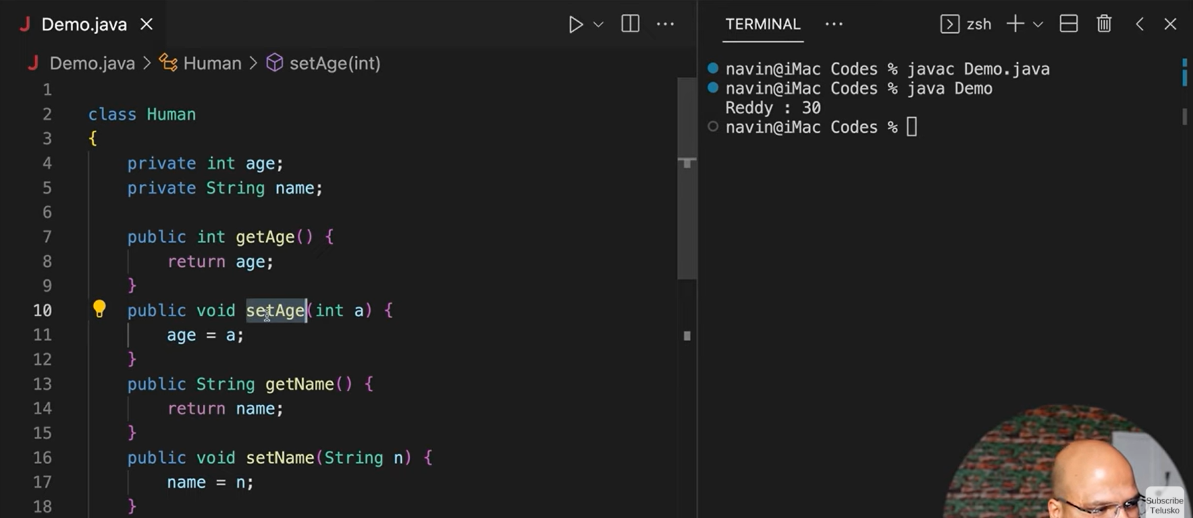
kj
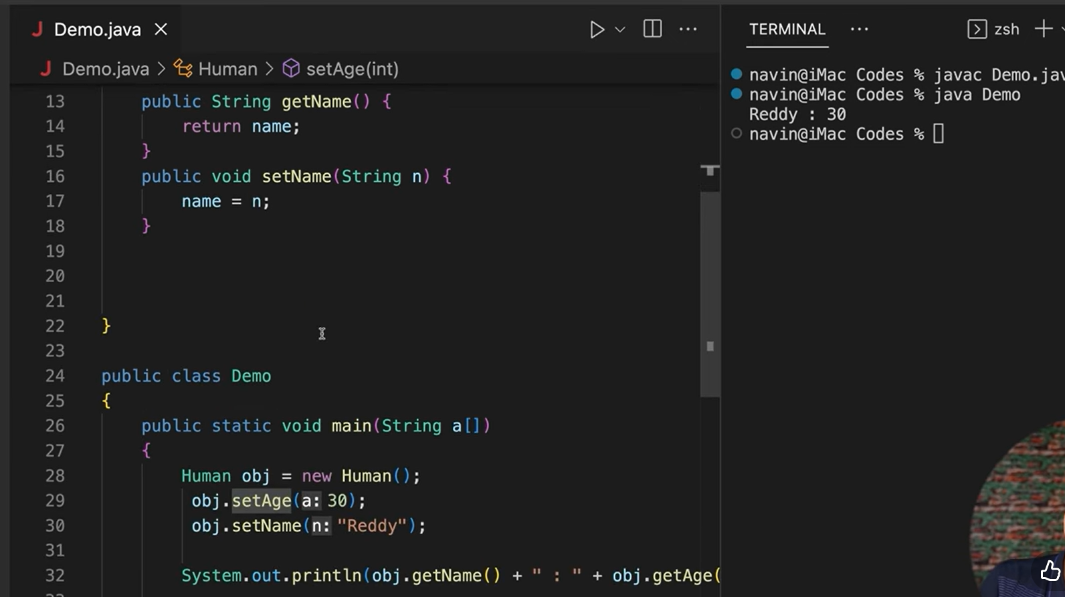
k

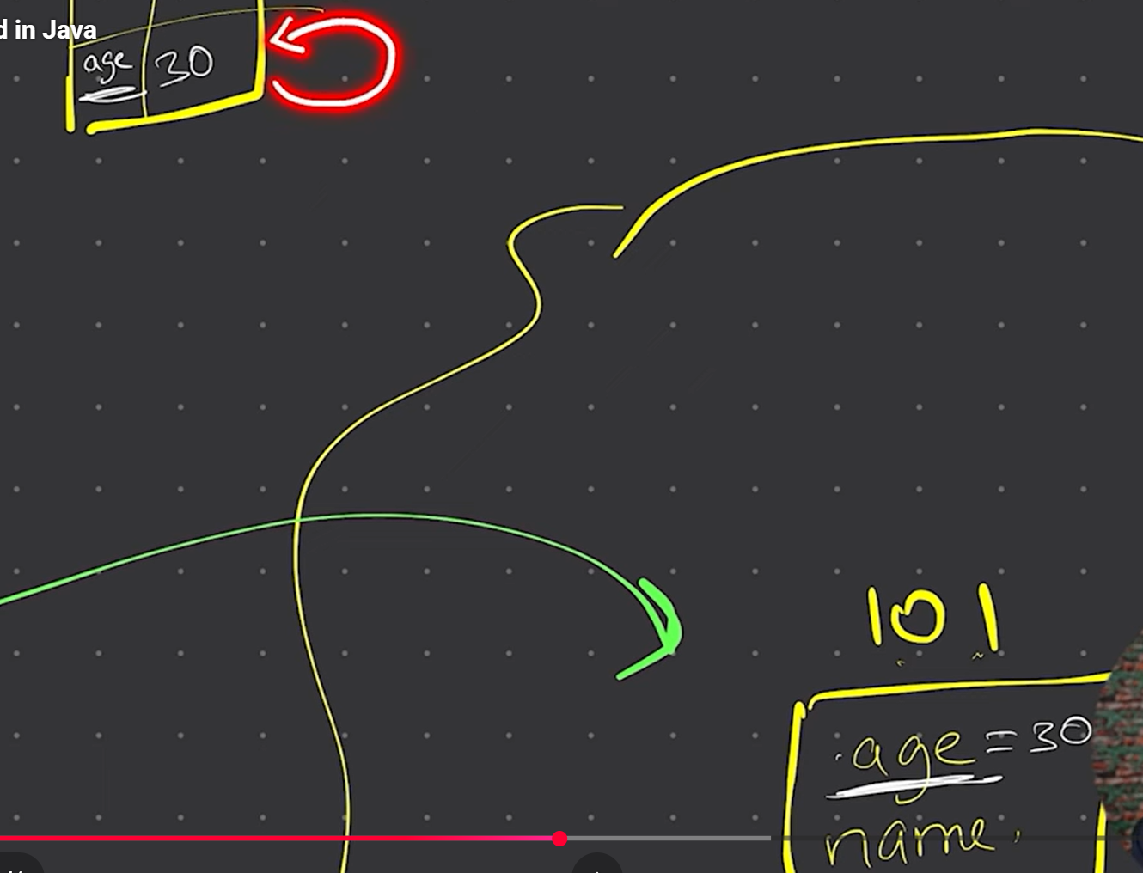
jh
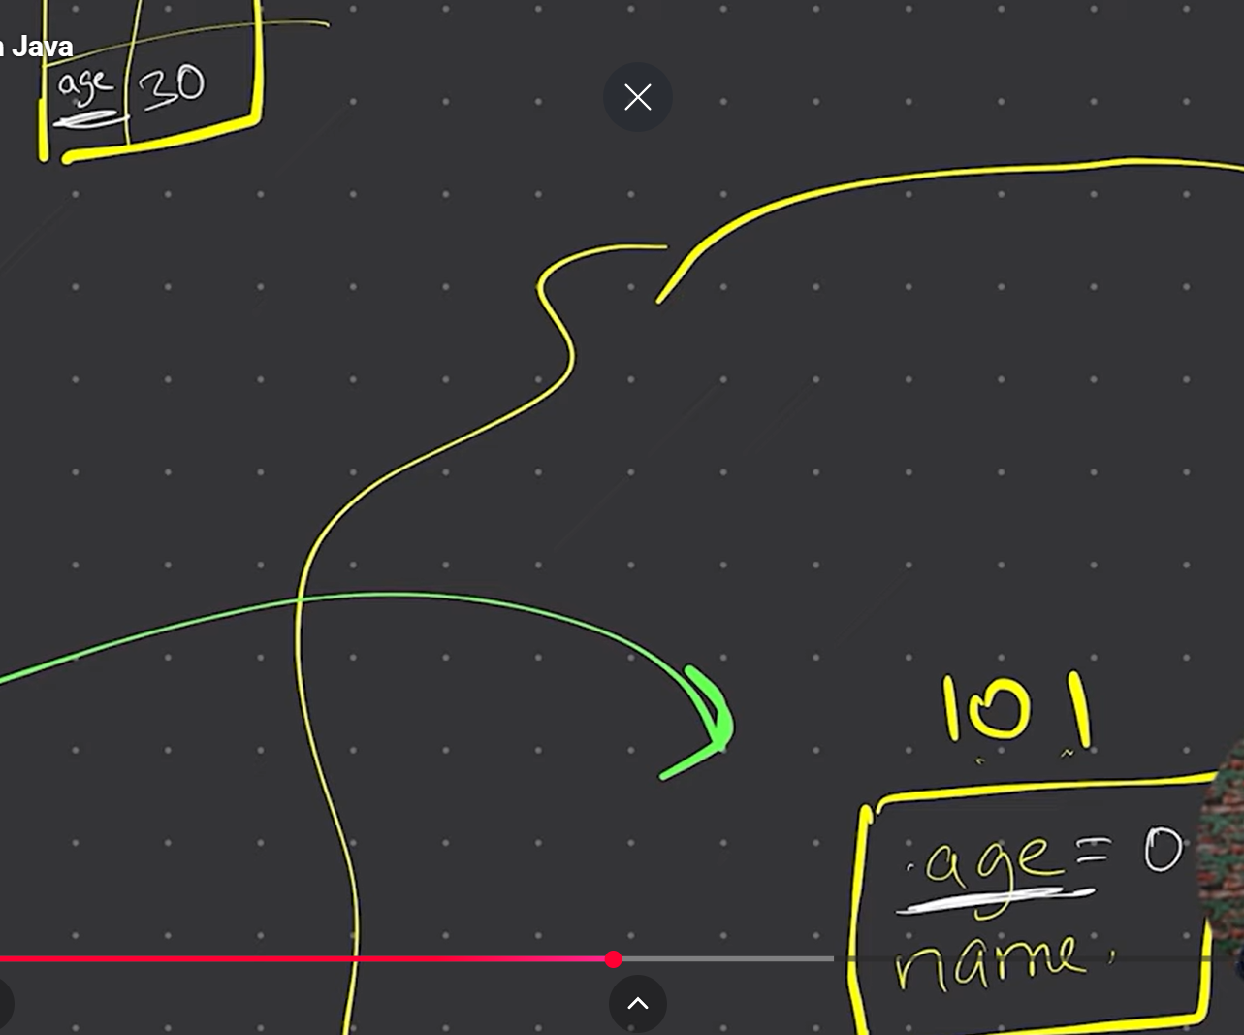
kj

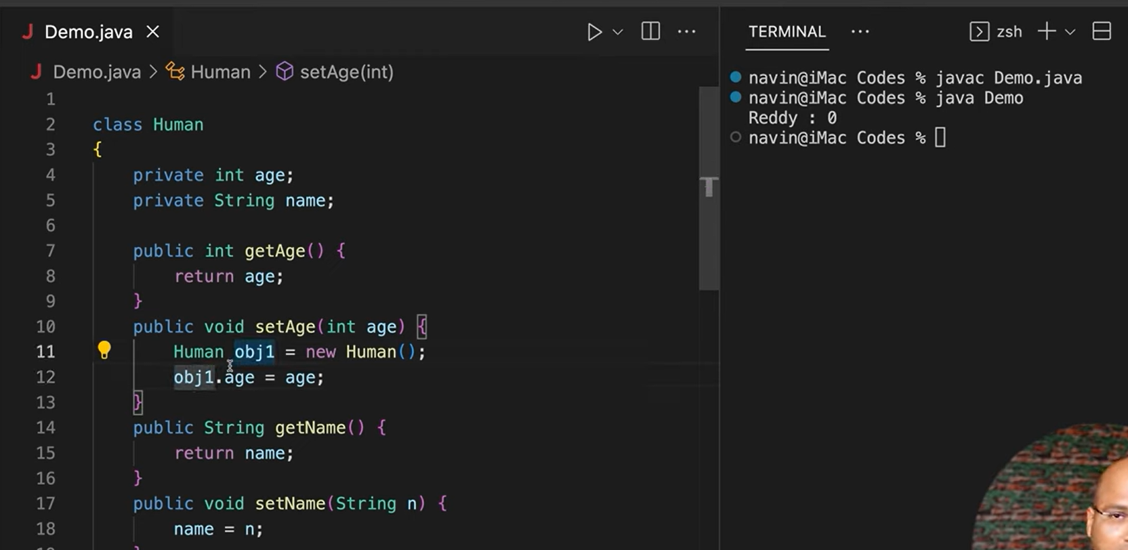
kj
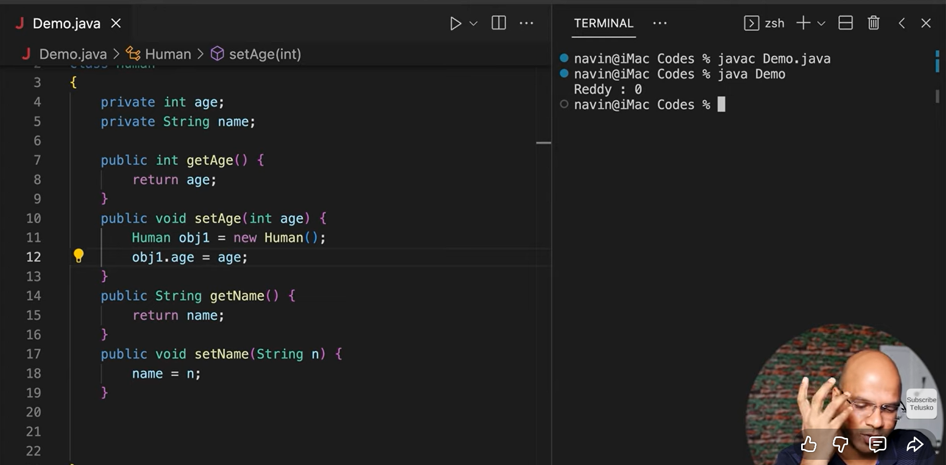
kgh
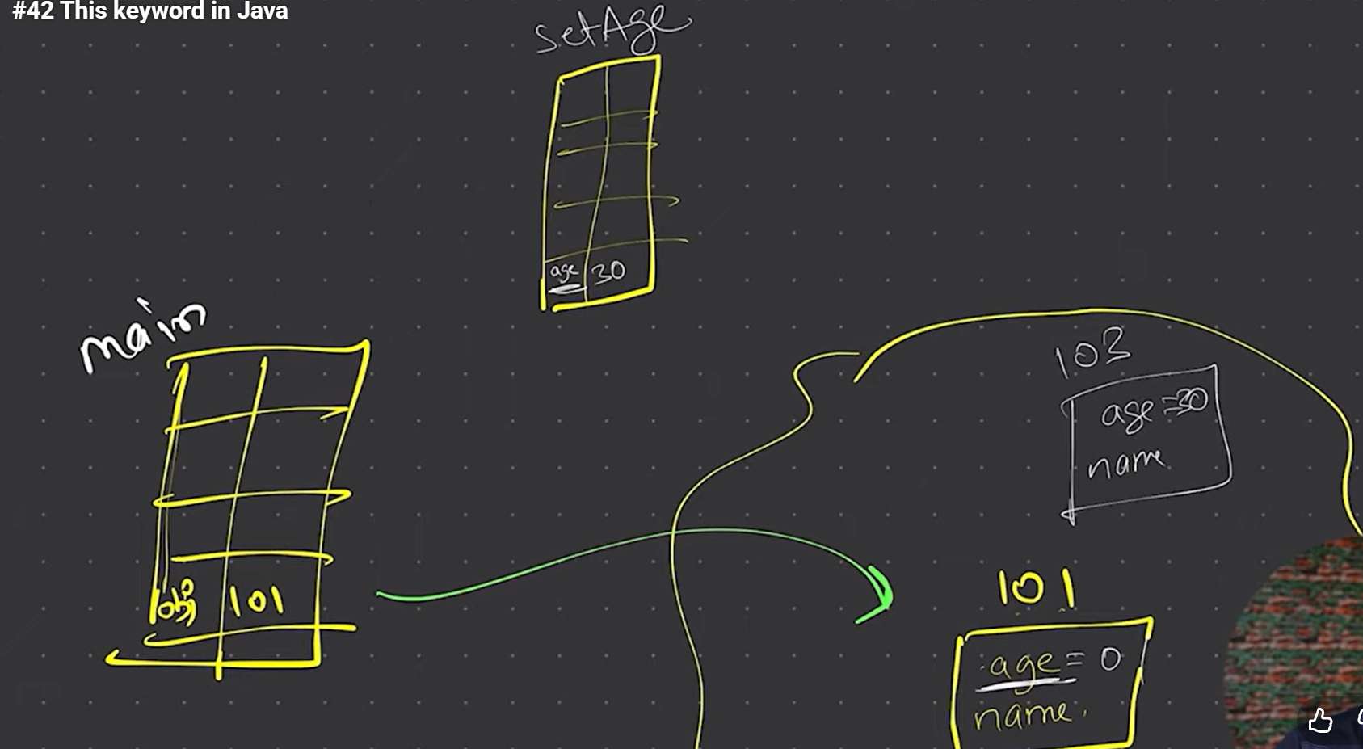
sfd
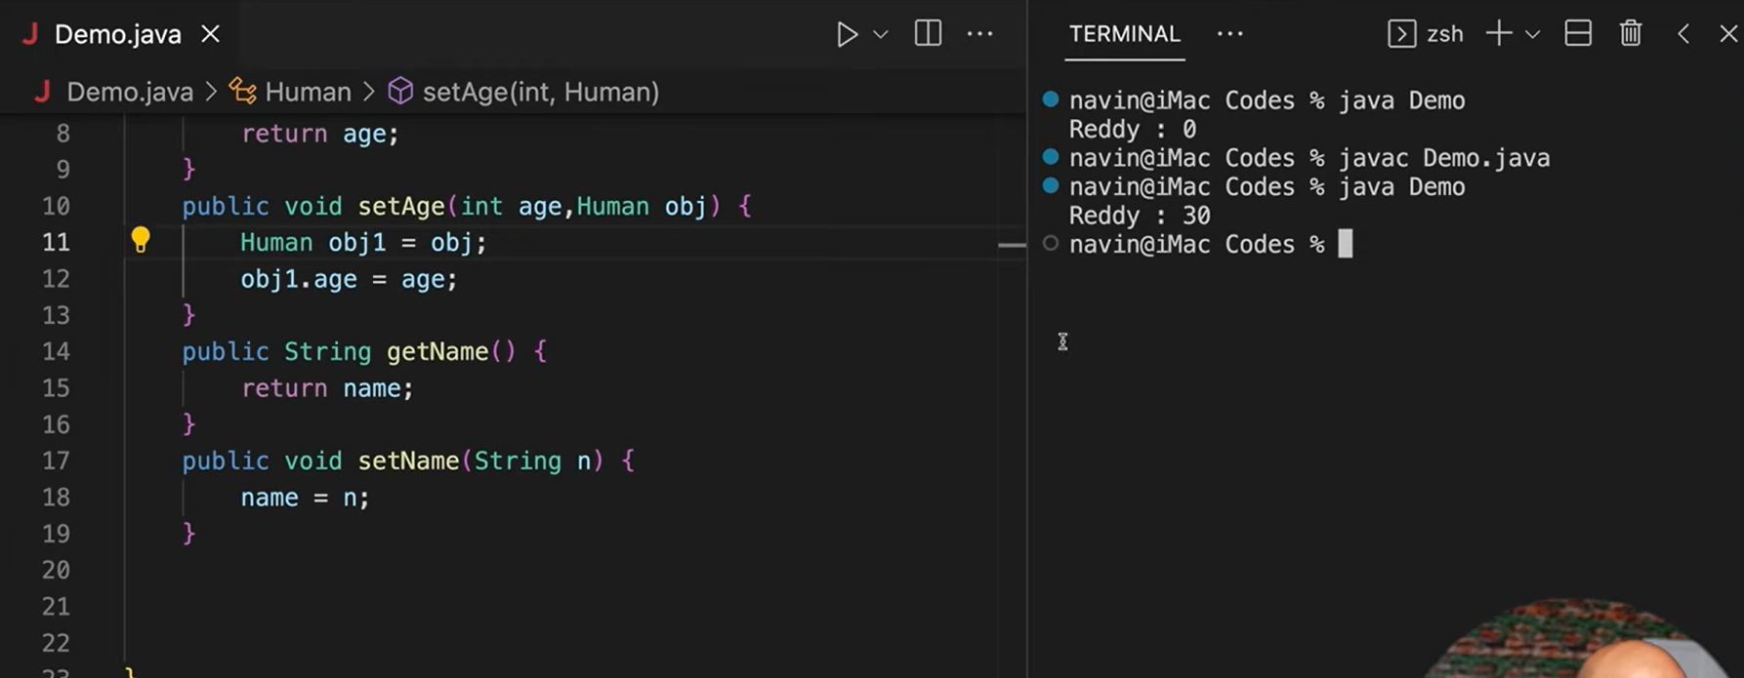
dfkj
In Java, this is a reference variable that refers to the current object —
the object whose method or constructor is currently being executed.
In simple words:
this = “the current object of the class”.

🧩 1️⃣ charAt() → When you need a specific character from a string

✅ Use when:
You just want one character at a specific position (index) from a String.

🧠 Syntax:
char ch = str.charAt(index);
- Index starts from 0 (like arrays).
- It returns one character.

🧮 Example:
public class ExampleCharAt {
public static void main(String[] args) {
String name = "Nisha";

// Get the 1st character (index 0)
char first = name.charAt(0);

// Get the 3rd character (index 2)
char third = name.charAt(2);

System.out.println("First character: " + first); // Output: N
System.out.println("Third character: " + third); // Output: s
}
}
✅ When to use:
- When you only need to check or use one or a few characters.
- For example, checking if the first letter is uppercase:
if (Character.isUpperCase(str.charAt(0))) {
System.out.println("Starts with uppercase!");
}

🧩 2️⃣ toCharArray() → When you need all characters in a String

✅ Use when:
You want to process or modify all characters — for example, looping, reversing, counting, etc.

🧠 Syntax:
char[] chars = str.toCharArray();
It converts the whole string into a character array.

🧮 Example:
public class ExampleToCharArray {
public static void main(String[] args) {
String name = "Nisha";

// Convert string to character array
char[] letters = name.toCharArray();

// Loop through each character
for (char ch : letters) {
System.out.println(ch);
}
}
}
✅ When to use:
- When you want to:
  - Loop through all characters
  - Modify or reverse a string
  - Count vowels, consonants, digits, etc.
Example — count vowels in a string:
public class CountVowels {
public static void main(String[] args) {
String str = "Nisha Prasad";
int count = 0;

for (char c : str.toCharArray()) {
if ("aeiouAEIOU".indexOf(c) != -1) {
count++;
}
}

System.out.println("Number of vowels: " + count);
}
}

🧾 Summary Table
Use Case | Method | Returns | Best For
Get a single character | charAt(index) | One character | Access by position
Work with all characters | toCharArray() | Array of characters | Loops, modify, count, reverse

